MINUTES

RMI ACWA Project Steering Committee Meeting

Date: 3rd , 9th and 14th June 2021
Venue: EPA Conference Room
Time: 13:00-1700 (3rd), 15:40-16:20 (9th) and 16:00-17:20 (14th)
In Attendance: (Annex 1: Sign in Attendance sheet)
Name | Organization | 3rd | 9th | 14th
Catalino Kijiner | Deputy Chief Secretary-Office of the Secretary (CSO) | X |  | X
Clarence Samuel | Director-Climate Change Directorate (CCD) | X
Lani Milne | CCD | X |  | X
Moriana Phillip | General Manger-Environnemental Protection Authority (EPA) | X | X | X
Kudo Kabua | Mayor WOTJE- Marshall Islands Mayors Association (MIMA) | X |  | X
Timmy Langrine | Director-National Disaster Management Office (NDMO) | X |  | X
Reginald White | Director- RMI Weather Station Service (WSO) | X
Lee Jacklick | RMI Weather Station Service (WSO) |  | X | X
Joy Kawakami | Acting Manager-Ministry of Culture, Internal Affairs, Gender Office | X | X
Daisy Alik-Momotaro | Director-Women United Together Marshall Islands (WUTMI) |  |  | X
Miram Debrum | Women United Together Marshall Islands (WUTMI) | X | X
Angela Saunders | International Organization for Migration (IOM) |  | X
Baren Jordan | International Organization for Migration (IOM) | X
Carrol de Bkum | International Organization for Migration (IOM) | X
Cathner Abner | UNDP | X | X | X
Tuvuki Ketedoromo | UNDP/EPA | X | X | X
Newton Lajuan | UNDP | X | X | X
Lizabeth Jack | UNDP | X | X | X
Roman Digno | UNDP | X | X
Jose Padilla | UNDP, via zoom | X | X
Nittaya Saengo | UNDP, via zoom | X | X | X
Winifereti Nainoca | UNDP via zoom | X | X | X
Louisa Katonibau | UNDP, via zoom | X
Roel Cabudsan | UNDP, via zoom | X | X | X
Koji Kumamaru | UNDP, via zoom | X | X | X
Francis Wele | UNDP, via zoom | X | X | X
Lemeki Rokovatulevu | UNDP, via zoom | X | X | X

Session1: Welcome & Opening
  - On behalf of the Chairperson of the Project Steering Committee (PSC), Mr. Clarence Samuel (CCD) welcomed all the PSC Members into the first Board meeting for the ACWA project and thanked the steering committee members for their time support to the ACWA project.
  - Levan Bouadze delivered a virtual opening remark on behalf of UNDP. He also showed his gratitude to the participants for the PSC meeting and highlighted UNDP commitment to work hand-in-hand with partners to increase resilience of water resources for people living on 24 of RMI’s most vulnerable outer Atolls and Islands.

Session2: Adoption of Minutes
The Chairman invited members to go through the Agenda of the meeting and was adopted. (Annex2: Meeting Agenda)

Session3: General Overview of ACWA project and ToR of Project Steering Committee Meeting
Winifereti presented the general background of the ACWA project and acknowledged huge support from GoRMI enabled to be granted for GCF ACWA project for water security in the RMI.
Terms of Reference (ToR) of the PSC was also presented by Koji and Responsibilities and Composition of the PSC member were summarized based on the description indicated in the Project Document (ProDoc) legally binding document between GoRMI and UNDP. Following points were discussed across the PSC meetings (3rd, 9th and 14th June) and endorsed.
Motion for Discussion | Response and Endorsement
- More clarification on the consensus of the TOR indicated below with the suggestion of replacement of UNDP RR to PSC member:  “In case a consensus cannot be reached within the Committee, final decision shall rest with the UNDP Resident Representative (RR).”  - GoRMI has requested for a chair and a vice chair within RMI. Chair by CSO and co-chair by EPA/CCD?  - CCD and EPA proposed to co-chair by Chief Secretary Office with UNDP  - Proposal for quarterly steering committee meeting, 4 meetings per year.  - Special meeting will also take place when necessary.  - Include MoCIA and MoWIU as members of PSC  - Positioning of the weekly ACWA meeting among EPA/CCD/UNDP | 1) This is the standard language in any ProDoc between Government and UNDP globally. In UNDP experience in the last 10 years for almost 100 boards, we have never reached this situation where the RR has to make the final decision as always consensus reach among PSC member. This paragraph will be observed during the following PSC meetings whenever necessary.  2) This is also standard modality of the PSC, co-chair by both Government and UNDP.  3) This suggestion was endorsed by PSC and will be proposed to CSO to co-chair by CSO and UNDP or designated representatives.  4) This is approved and endorsed by PSC  5) This is approved and endorsed by PSC  6) This is approved and endorsed by PSC  7) Weekly ACWA meeting can be positioned as a Technical-Working group to discuss the project progress regularly and bring any proposal and/or significant changes to PSC meeting for official endorsement-approved and endorsed by PSC
Session4: Risk Table and Safeguards
Roel also presented Social and Environment Safeguards while Risk table was summarized by Cathner and presented factors that could possibly adversely affect the delivery of the project outcomes, namely
- Exclusive reliance on government scheduled boat and chartered boat to outer islands limit the delivery of outcomes in a timely manner
- Building ownership of wells in project locations can cause delays and limit the successful implementations of water security interventions.
- Water security interventions may not withstand climate change impacts especially increased intensity cyclones
- High staff turnover and limited local human resource base
- Political Risks; Changing leadership at national and local level
- COVID-19 impacts on travel inbound and outbound travel restrictions for project related staffs and delay procurement and supply, particularly rainwater harvesting storage system and protection material for groundwater wells.
Motion for Discussion | Response and Endorsement
- Risk table to be corrected due to typo error.  Water Security is unequivocally a national priority and support is highly unlikely. (Risk & Safeguards PPT, pp.4)  - Can we use local material though it’s indicated Social and Environment Risk Management?  “Material, such as concrete blocks will be imported, as domestically produced blocks may utilise materials sourced from the reefs around RMI.” (Risk & Safegurads PPT pp.7)  - Is there a possibility to see an initial design or concept design of these tanks with barrage? | 8)Corrected below.  Water Security is unequivocally a national priority and support is highly likely.  9) If quality materials are available locally the project can use this its cost saving if doesn’t impact on environmental risk and degradation.  10) Yes, we shall share once developed.

Session5: ACWA Project Update
Budget and expenditure for 2020-2021 was presented by Lemeki as per below summary table.
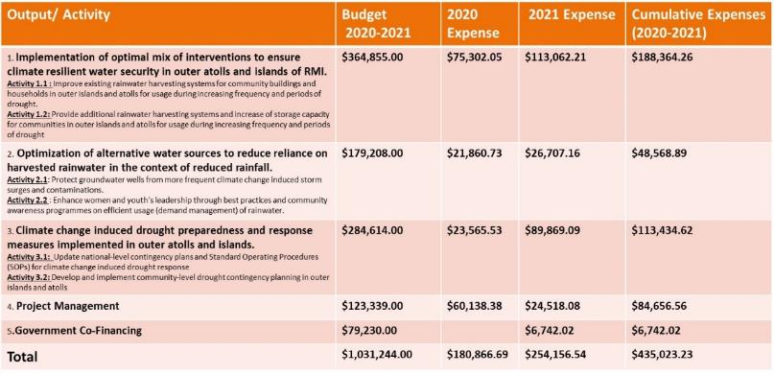
Progress of ACWA project and the plan for 2021 was shared by Koji.

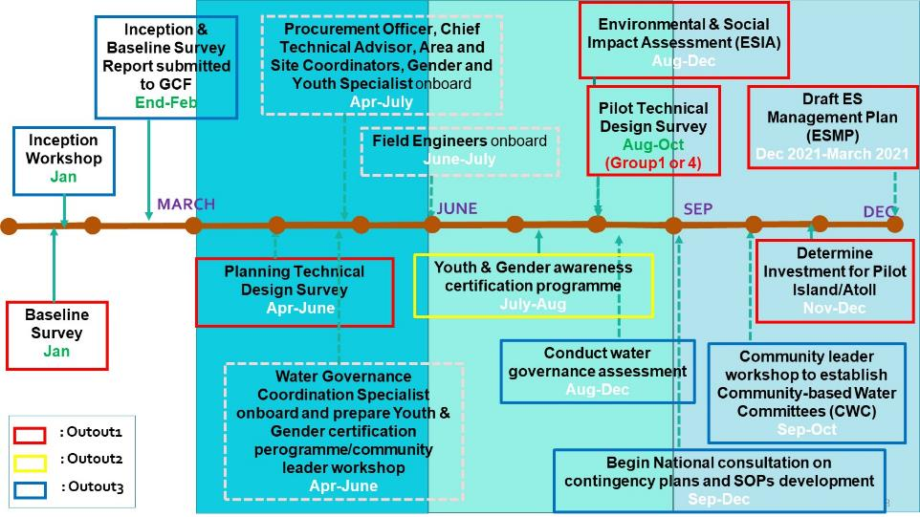

Motion for Discussion | Response and Endorsement
- Additional financial information can be provided to the committee members upon request.  - How to ensure the quality of construction works on rainwater harvesting system and groundwater well rehabilitation.  - Need joint review with NDMO/EPA/UNDP for Output3 on national-level contingency plans and SOP for climate change induced drought as there is no such thing for the record a "National Contingency Plan" for Drought Response. Instead of "update" why don't we use this project to "develop" national contingency plan for drought response?  - This will require an in-depth partners coordination efforts that we don't duplicate efforts that are currently undertaken. E.g. NDMO is working with Outer islands in developing Disaster Risk Management Plan for each of the outer islands. NDMO has a template already and it has completed 3 outer islands.  - Would like to know or see the outcome report of this inception workshop. What were their initial findings from the workshop, etc.  - Instead of starting with group of atolls that has sufficient rainfall every dry season, why don't we start Technical Design Survey (TDS) with the ones are most vulnerable to drought?  - MIMA are not in the list of implementing partner (Responsible parties). | 11) Upon request, UNDP will prepare and provide financial information.  12) Recruited qualified engineers, plus technical oversight by Chief Technical Advisor. They will supervise the installation/construction works and community will be trained simple O&M (Operational & Maintenance) skill.  13) As long as there is no duplication of the work, no issue either “update” or “develop”. EPA and UNDP will set up meeting with NDMO to discuss activities related to Output3.  14) ditto.  15) Inception Report will be shared together with baseline report.  16) Fully acknowledged the suggestion by PSC member and endorse to start Group4 for pilot technical design survey while flexibility remain with subject to the unforeseen situation and timeline for GCF 2nd disbursement condition.  17) WSO and MIMA are included as part of Responsible Parties. (‘Implementing Partner’ is only UNDP as per ProDoc, and other partners are called ‘Responsible Parties)

Session6: Project Management Unit (PMU)
Wini has presented PMU structure indicated in the ProDoc and following points were elaborated.
- Water Governance Coordination Specialist:
This position is actually not new and originally budget is specified this position in the ProDoc, but not clearly indicated in the narrative part of PMU.
- Field Engineer Associate:
Given the lack of pool of qualified Marshallese engineers on the ground, non-Marshallese qualified engineers were recruited under same national contract modality upon the agreement with EPA and CCD. In order to broaden the opportunities with Marshallese from the view point of building capacity, proposal is to create new Field Engineer Associate positions with lower minimum qualifications compared with solid qualifications of Field Engineer positions. If we create Engineer Assistant positions, we can have one Engineer and one Engineer Assistant in one team. Recruited Filed Engineers, Roel and Roman, have extensive skill and experience for civil engineering works, hence can build capacity for the Assistants as well. Ideally, we want to have 3 Field Engineers and 3 Field Engineer Associates but would like to be flexible depending on the qualified candidates and budget availability. In the ProDoc, “2” Field Engineers indicated in the narrative of PMU structure, but in the budget line, “4” Field Engineer’s budget is secured.
- Site Coordinators:
There is discrepancy of Site Coordinator position indicated in the ProDoc in terms of the budget and the contract type. We’ve closely discussed this issue among CSO, MIMA, EPA, CCD and UNDP upfront the PSC meeting, and reached consensus to make Site Coordinator contract by RMI EPA contract with the condition of a) part time (26hrs/week), $3/hour, and then total number of Site Coordinators will be 30. The reason of 30 Site Coordinator is that principally, we will have 1 Site Coordinator per 1 Island. Then, Islands with bigger number of target communities/villages, such as Ailinglaplap, Maloelap, Arno, Mili, Jaluit, Ebeye, these islands can have 2 Site Coordinators per island.
- Community Engagement Specialist:
We revisit their role & responsibility, and we identified the type of work is completely overlapped with Area Coordinators, Site Coordinators and Water Governance Specialist positions. In order to streamline the work, the proposal is to converge Community Engagement Specialist position with Area Coordinator positions. By this convergence, it enables to reallocate budget within HR for required extra budget for Site Coordinators positions as indicated above.
- New UNDP contract modality
Just launched the National Personnel Services Agreement (NPSA) from 1st June 2021. The NPSA will replace the existing Service Contract (SC) modality including Service Board Contract (SB) for UNDP globally including RMI and Fiji.
There are several changes of benefits from SC to NPSA, however, the RMI NPSA salary scale is not attractive since there has not been any salary revision since 2013. Therefore, need reclassification of those existing vacancy positions. For instance, if the position advertised as SB3, the position will be reclassified the NPSA level equivalent to SB4, this is simply to balance out the salary level.

During the discussions in the PSC meeting, all proposed changes on the PMU structure above were approved and endorsed by PSC members except the convergence of Community Engagement Specialist and Area Coordinator positions. At this stage, it’s difficult to judge whether the role and responsibility of Community Engagement Specialist position is completely overlapped with existing roles and responsibilities of Site Coordinators, Area Coordinators and Water Governance Coordination Specialist, or there will be a gap to be filled by Community Engagement Specialist position. This discussion will be subject to the progress of the forthcoming Technical Design Survey exercise.

Session7: Endorsement
Following the deliberation of the committee, the following was approved and endorsed:
- The updated ToR of Project Steering Committee (PSC)
- The updated risk logs
- The budget and workplan for 2021
- The Project Management Unit (PMU) structural update and change
- The Responsible Parties including Environmental Protection Authority (EPA). (Annex3)
Session8: Action Points and Other Business (AOB)
Action Points:
Action Point | By Whom
- Share written opening remark by UNDP RR (requested by CSO) | UNDP
- Send notification letter on decision and nomination for CSO to co-chair the PSC meeting with UNDP | UNDP & EPA
- Share Inception Report and Baseline Report | UNDP & EPA
- Update Project Risk Log in ATLAS | UNDP

Presentation materials used in each session that were the basis of approved and endorsed points in the PSC meeting can be found in the Annex 4.

Annex 1
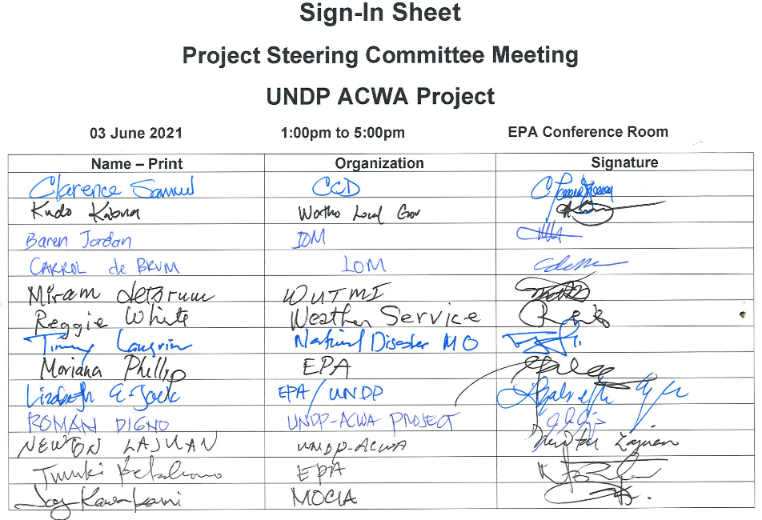
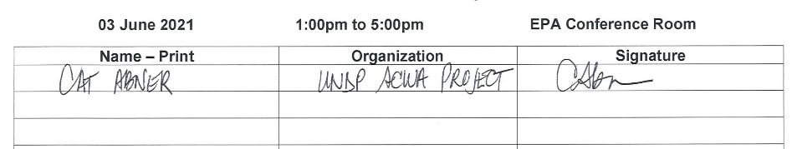
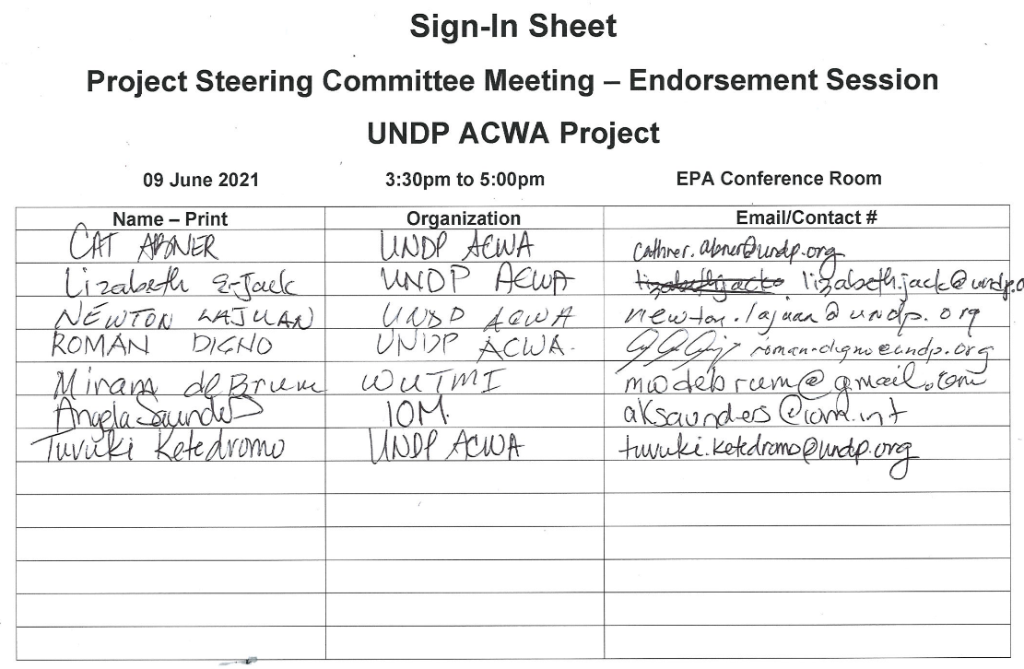
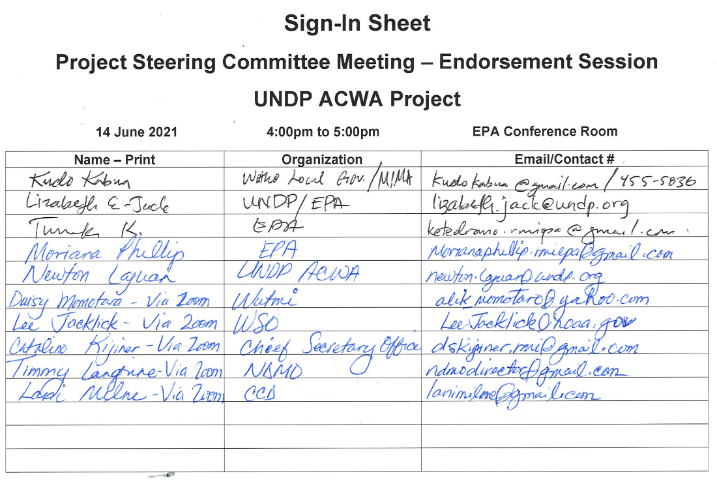

UNDP and Project Team (Join Virtually Via Zoom)

Jose Padilla | UNDP Regional Technical Advisor | Bangkok
Nittaya Saengow | Programme Associate | Bangkok
Roel Cabudsan | Field Engineer | Philippines
Winifereti Nainoca | UNDP RSD Team Leader | Fiji
Koji Kumamaru | Project Manager | Fiji
Francis Wele | Deputy Project Manager | Fiji
Lemeki Rokovatulevu | Admin/Finance Assistant | Fiji

Annex 2: Agenda
Date: Thursday 3rd June 2021
Venue: EPA Conference Room
Time: 1300hrs-1700hrs.
Session 1 Welcome and Opening
1300 – 1325 | - Welcome and Opening speech by Chairman  - Opening Remarks by UNDP | - GoRMI: General Manager of EPA Moriana Phillip  - UNDP Resident Representative Levan Bouadze
Session 2 Adoption of Meeting Agenda
1325 – 1330 |  | GoRMI: CCD Director Clarence Samuel
Session 3 General Overview of ACWA project and ToR of Project Steering Committee
1330 – 1400 | - General Overview of ACWA Project  - ToR of Project Steering Committee | UNDP: Team Leader Winifereti Nainoca  : Project Manager Koji Kumamaru
Session 4
1400 – 1430 | - Risk Table and  - Social & Environmental Management Safeguards | UNDP: Admin & Finance Officer Cathner Abner  : Field Engineer Roel Cabudsan
Tea Break
Session 5
1445 – 1530 | - Finance Report  - Annual Work Plan | UNDP: Admin & Finance Associate Lemeki Rokovatulevu  : Project Manager Koji Kumamaru
Session 6 ACWA Project Update
1530 – 1600 | - Update on the Project Management Unit structural changes. | UNDP: Team Leader Winifereti Nainoca
Session 7 *
1600– 1640 | - Endorsement for plan, proposed change in the ACWA project | EPA: Moriana Phillip  UNDP: Deputy Project Manager Francis Wele
Session 8
1640 – 1700 | - Other Matters  - Closing Remark | CCD: Clarence Samuel
END OF PROJECT STEERING COMMITTEE MEETING
*Due to time constrain, the Session 7 was postponed to Wed 9th June. However, power outage at EPA conference room, the PSC meeting on Wed 9th Junewas intermittent, hereby, re-scheduled to Monday 14th June for session 7.

Annex 3: Responsible Parties
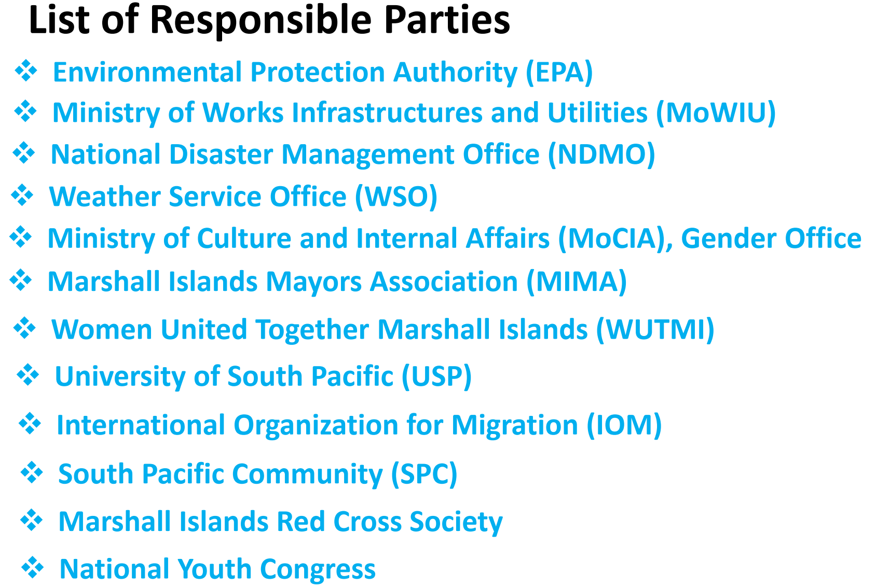
Annex 4: Presentation material during the PSC meeting
Sesssion3
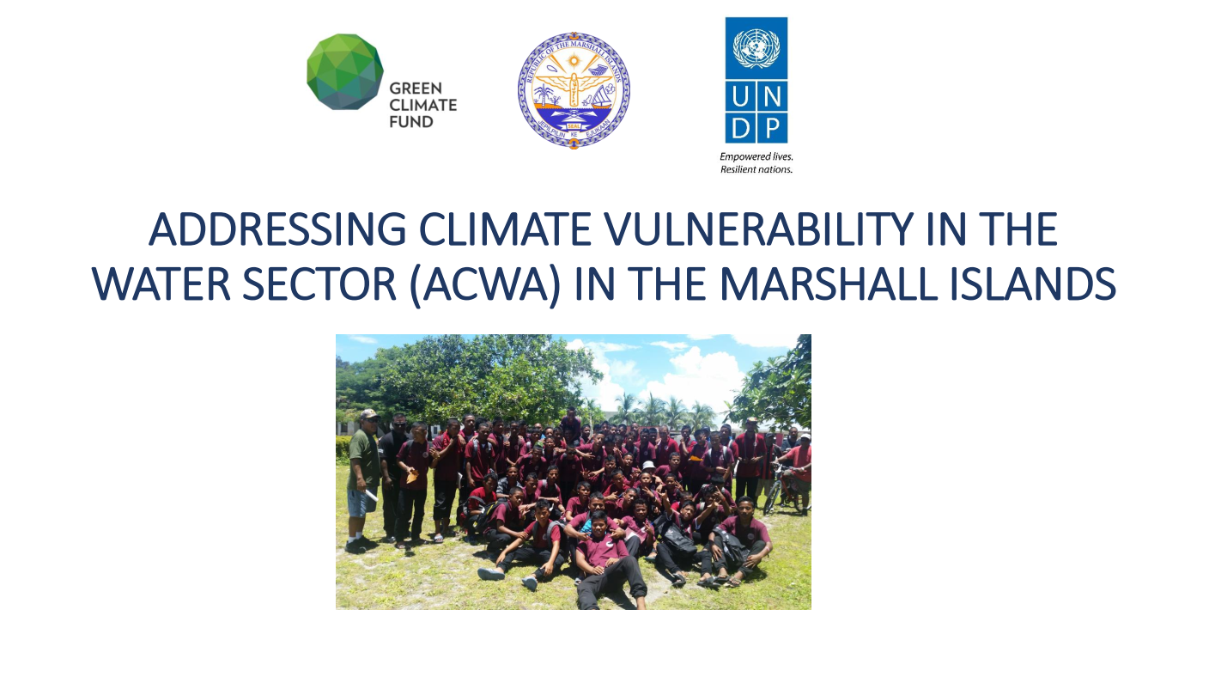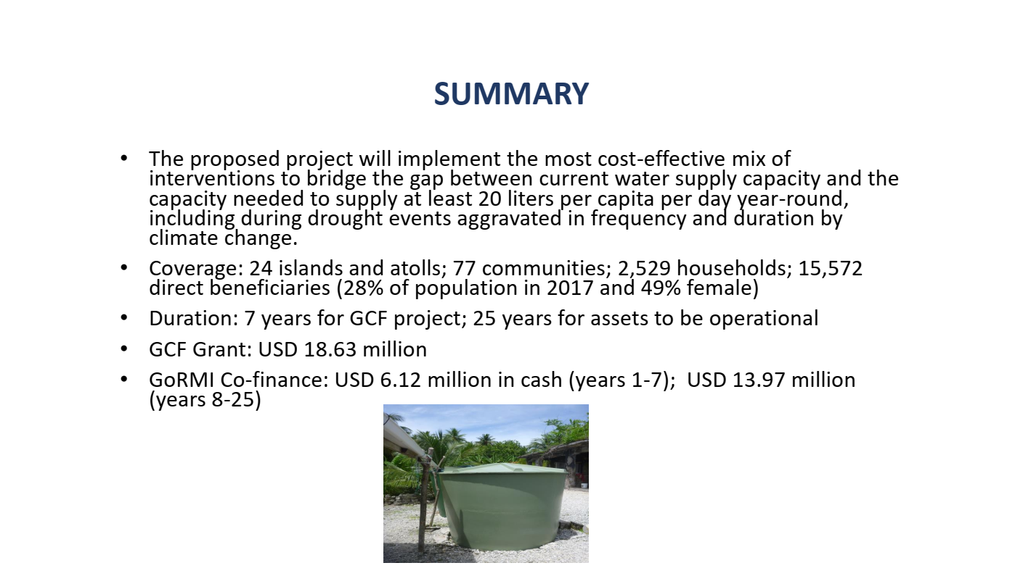

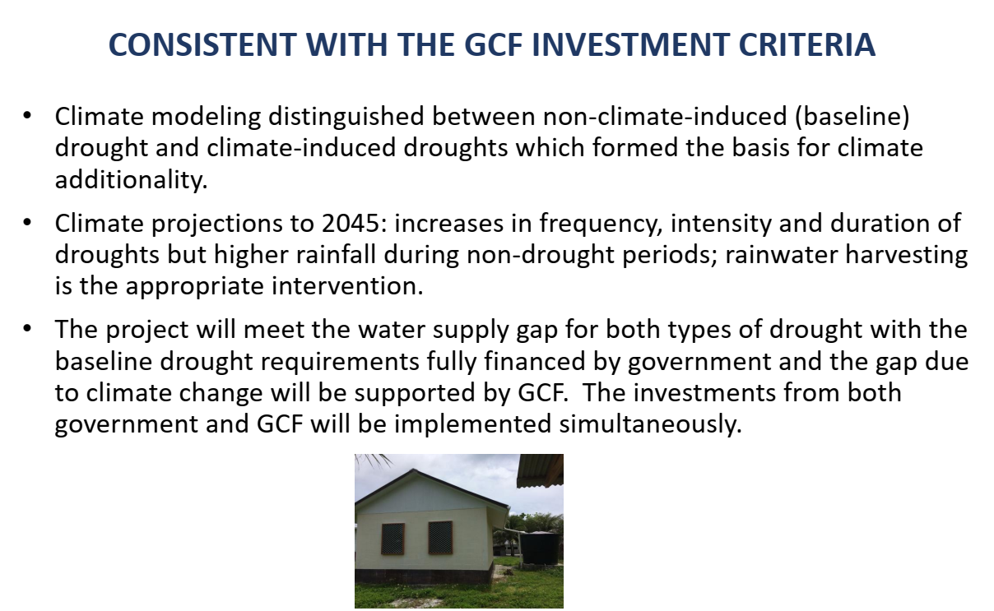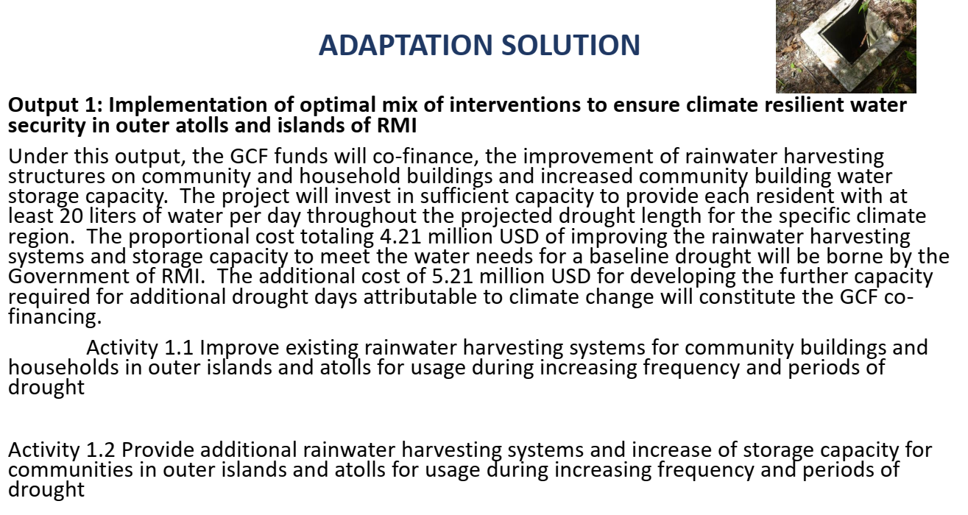
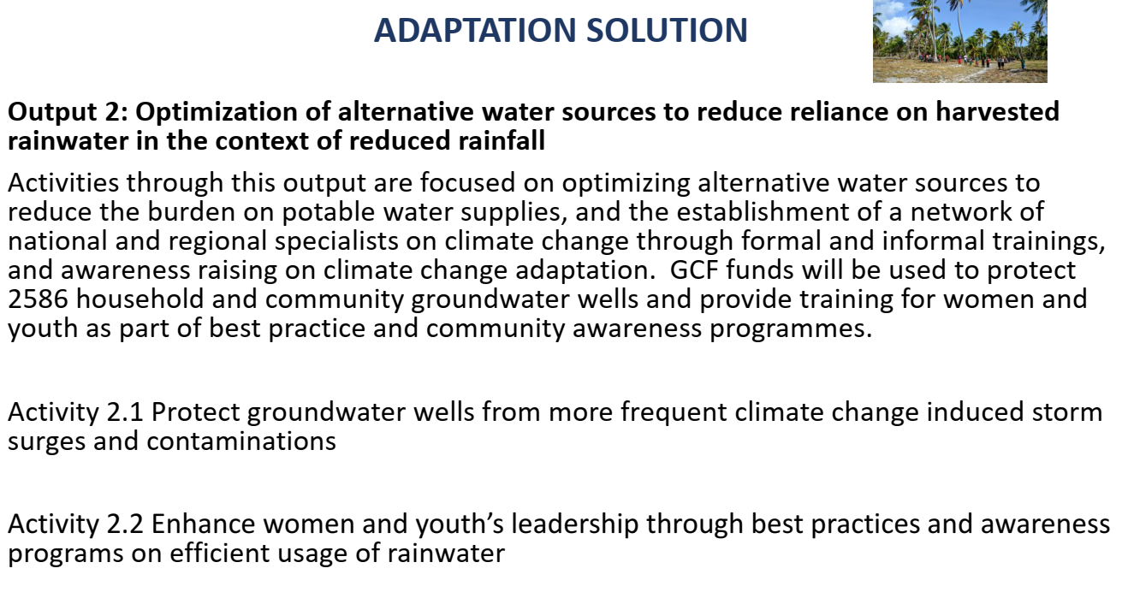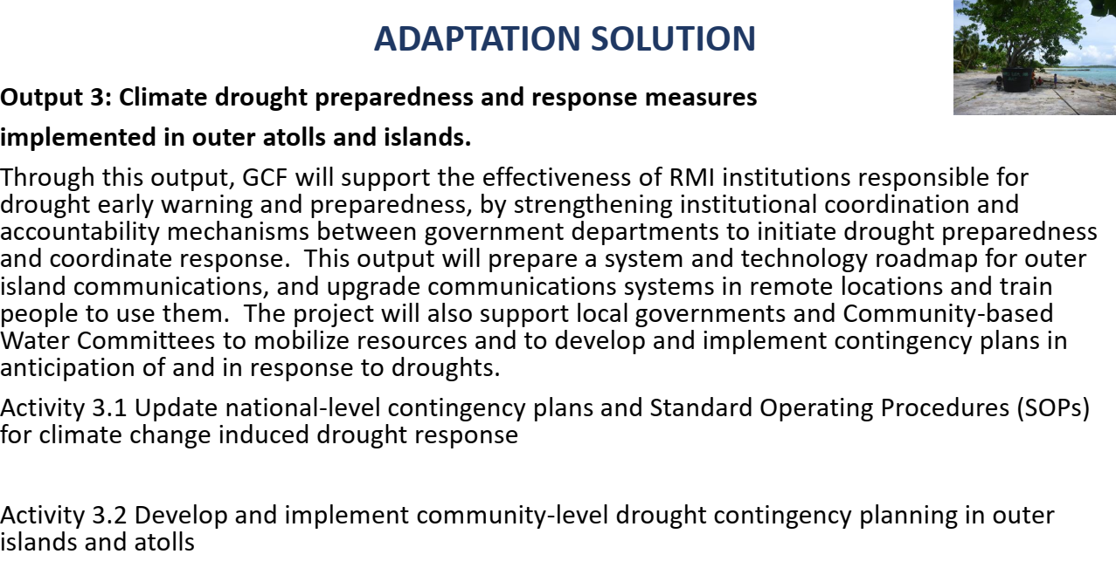
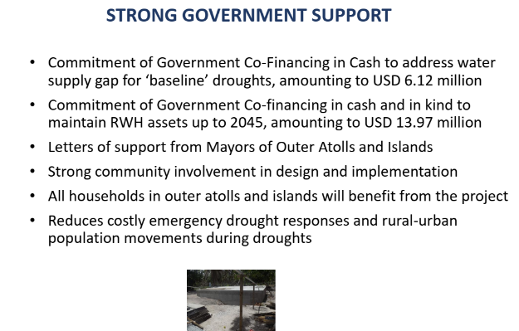
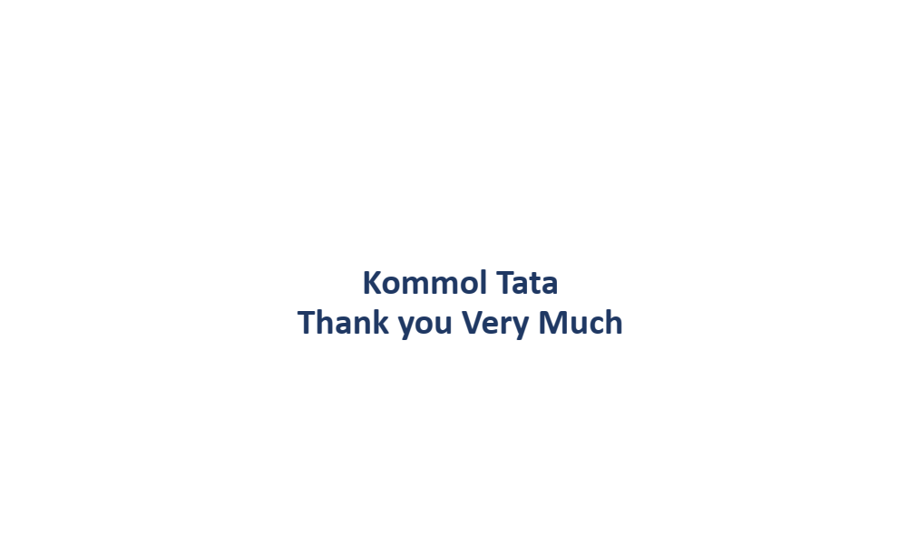
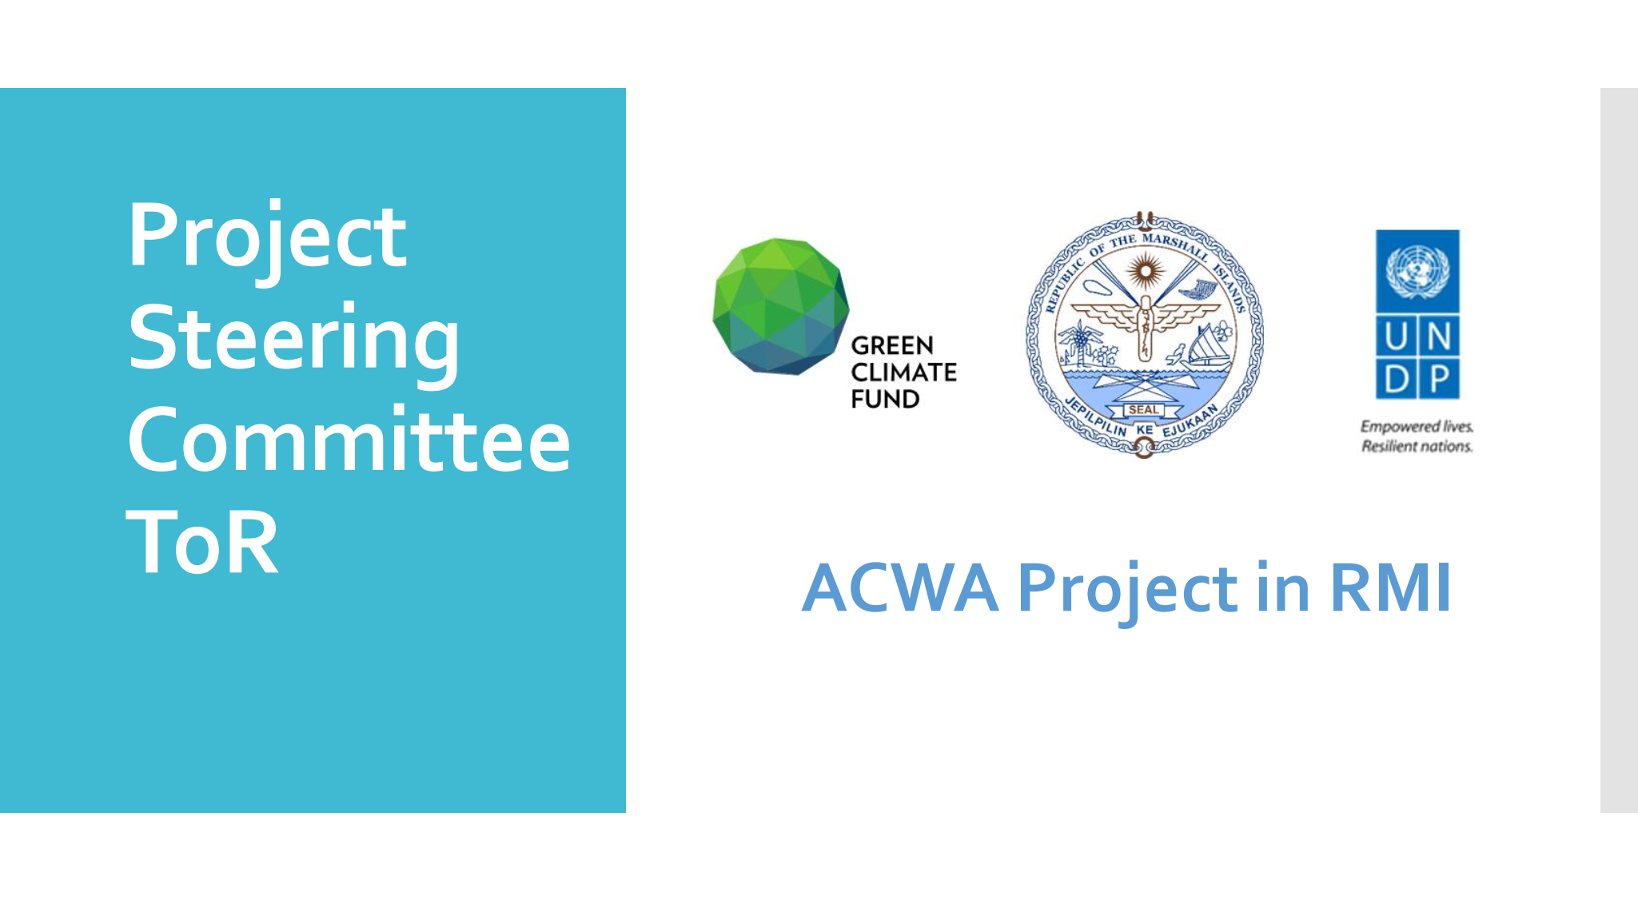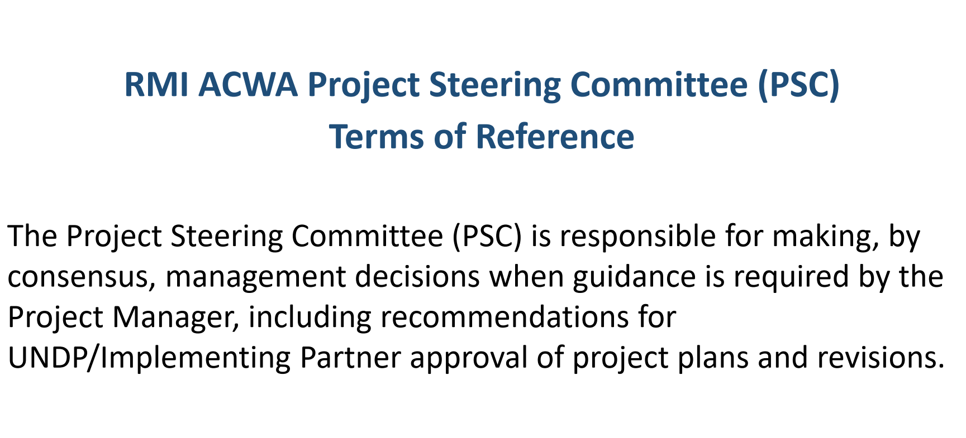
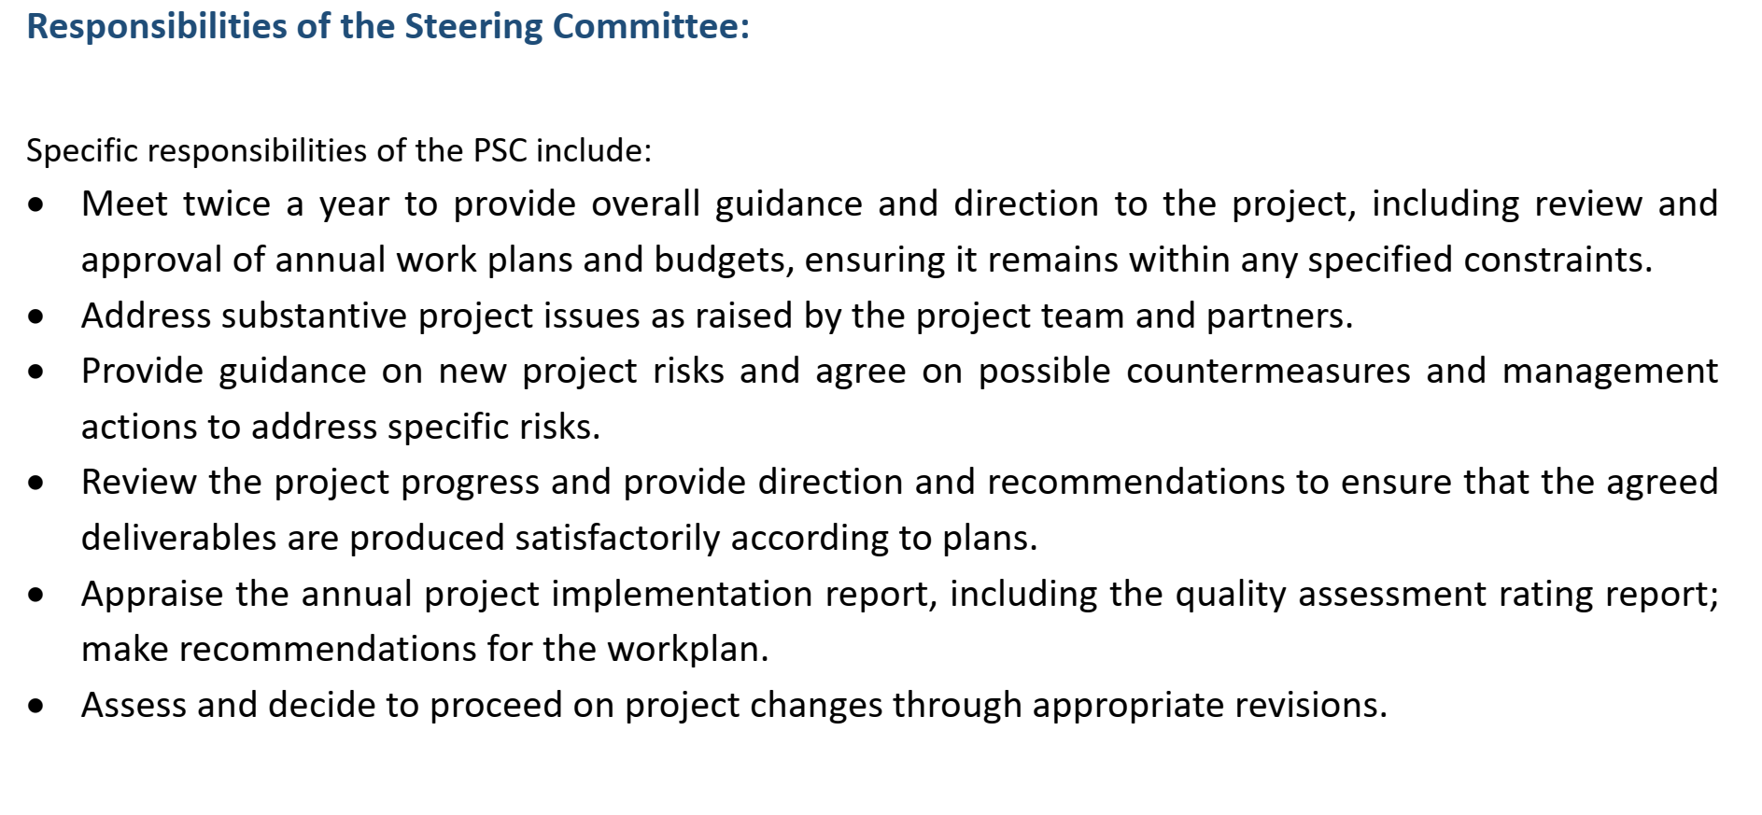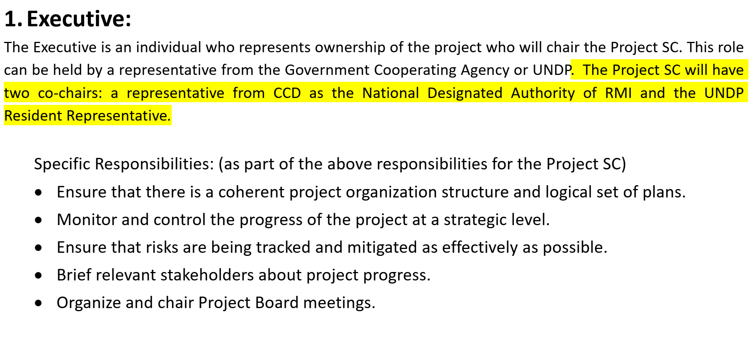
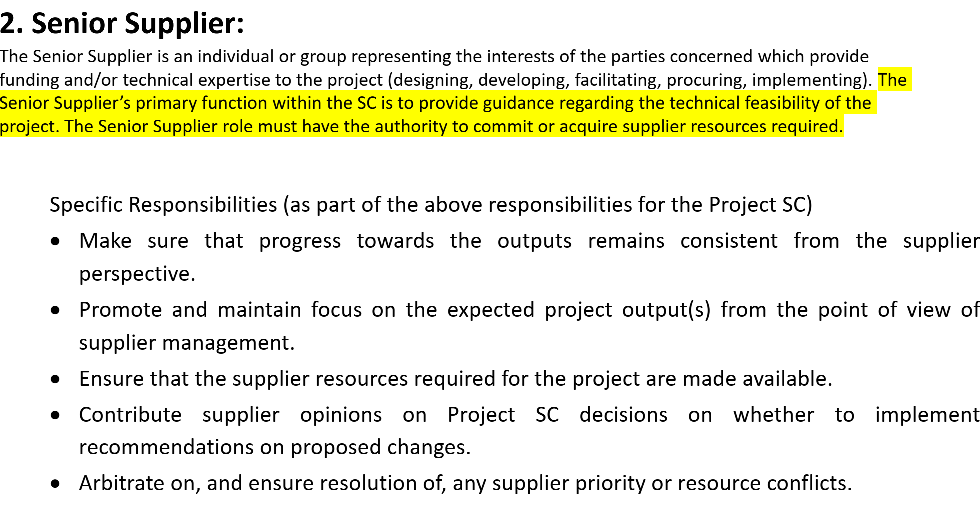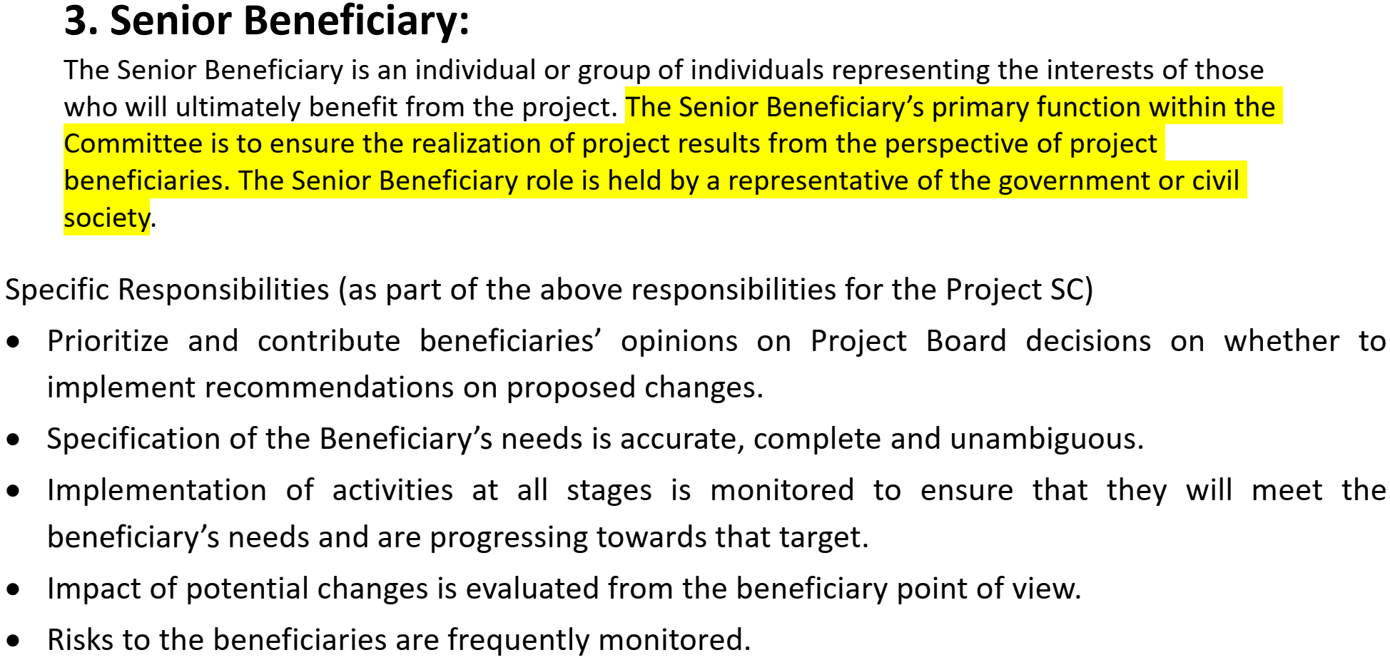
Session4
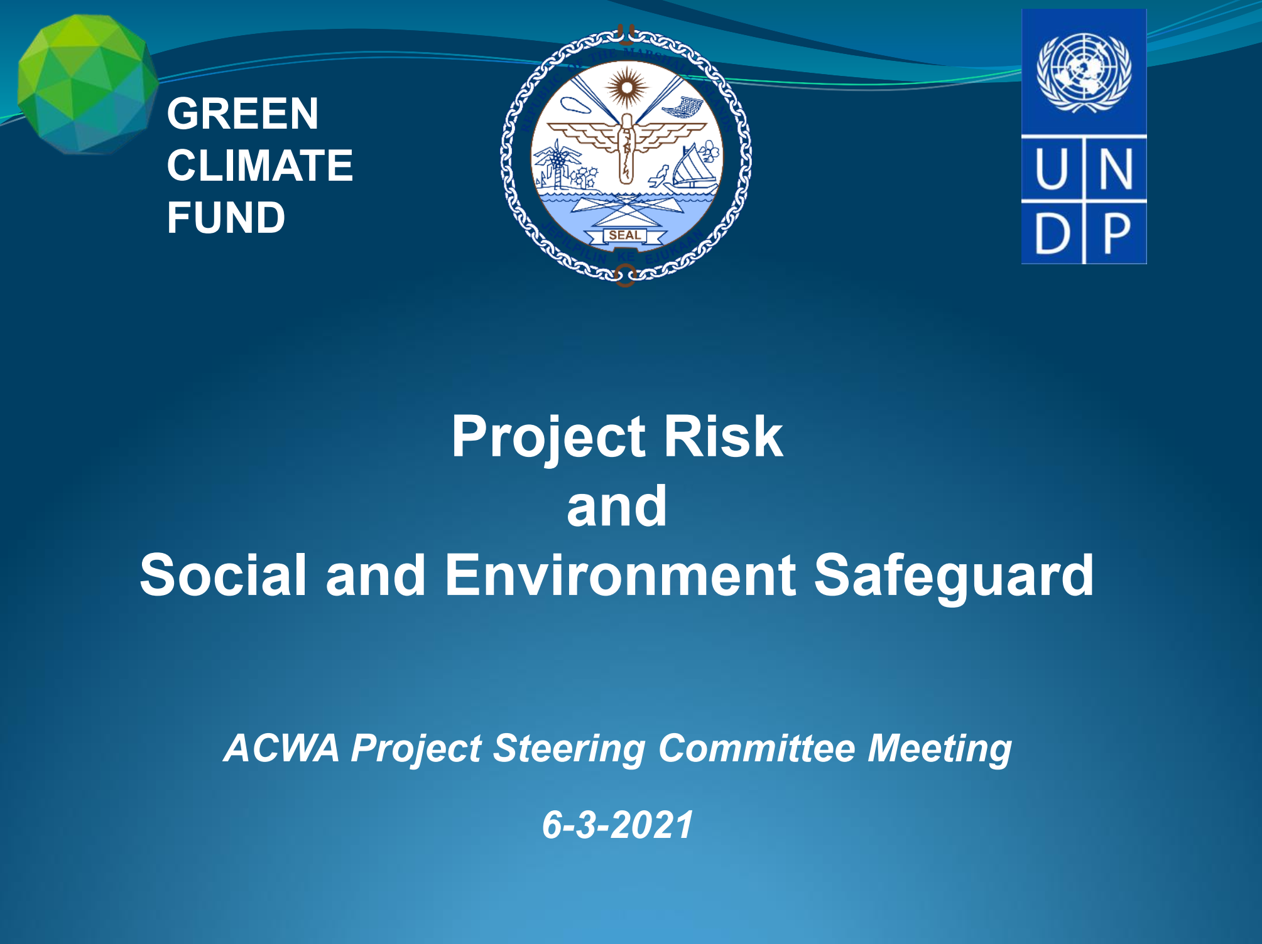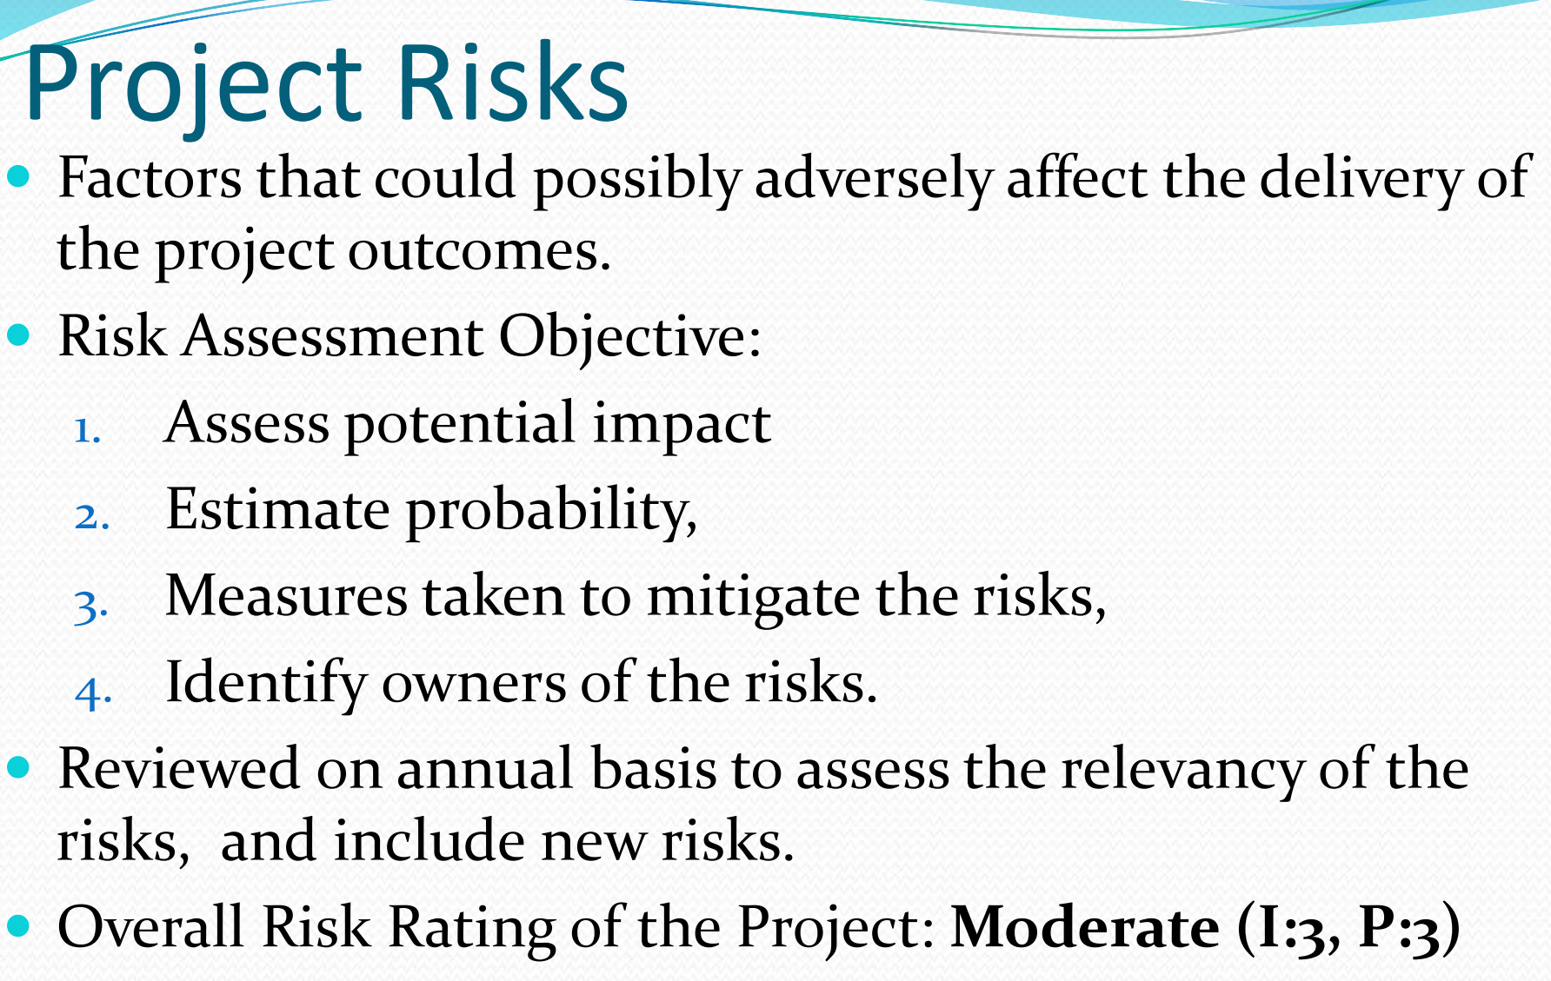
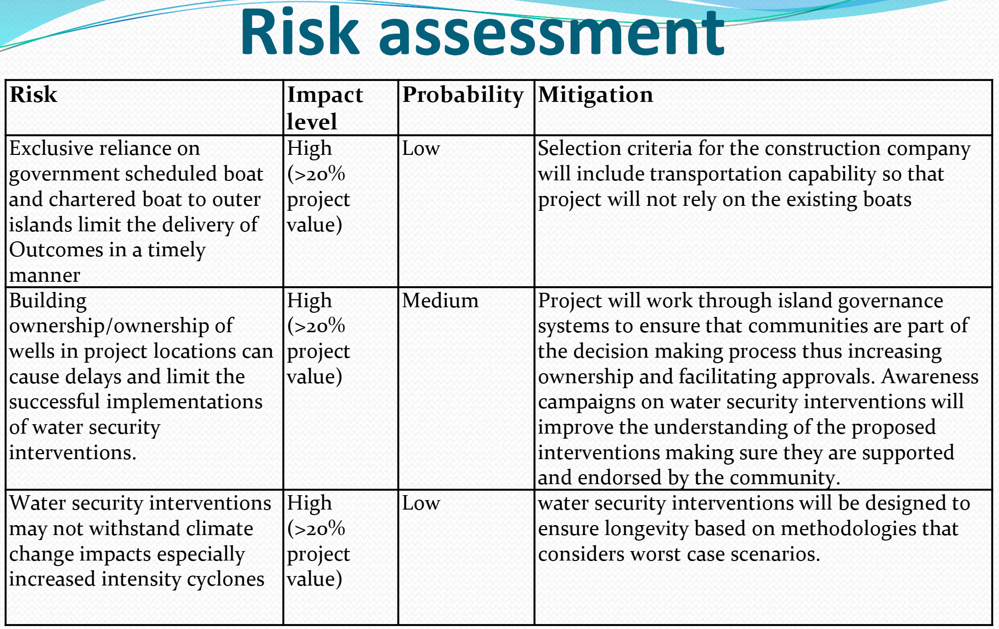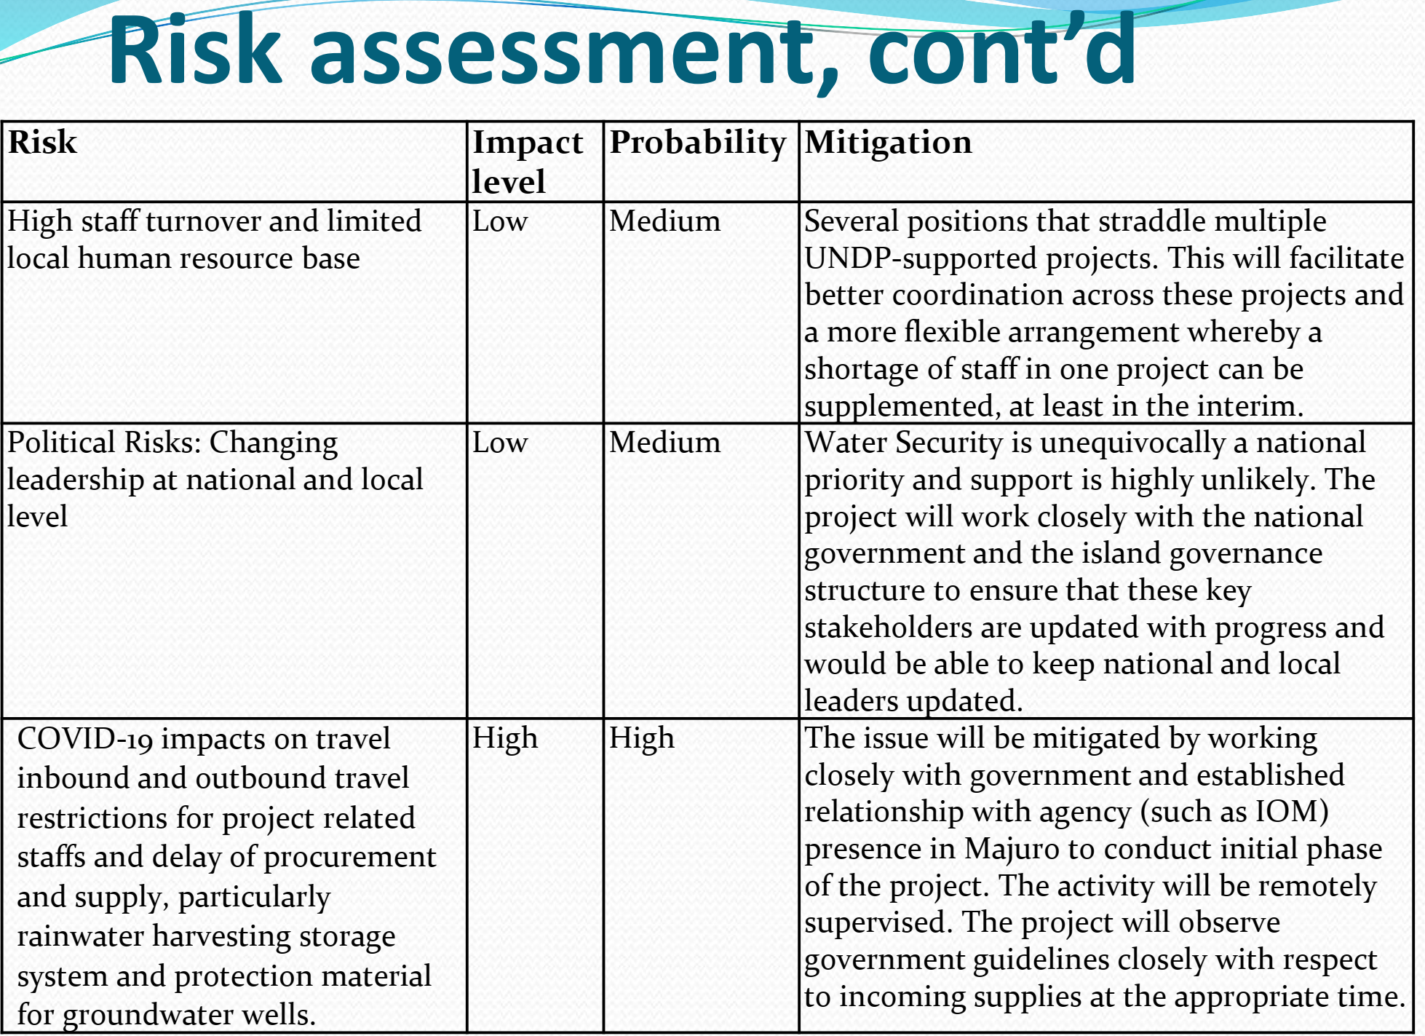
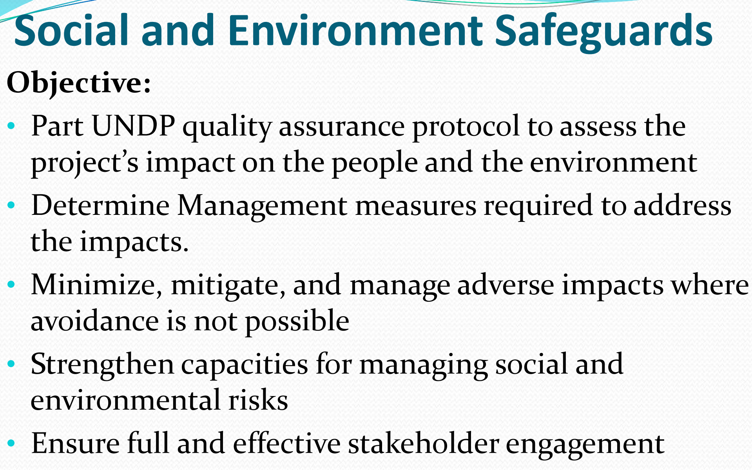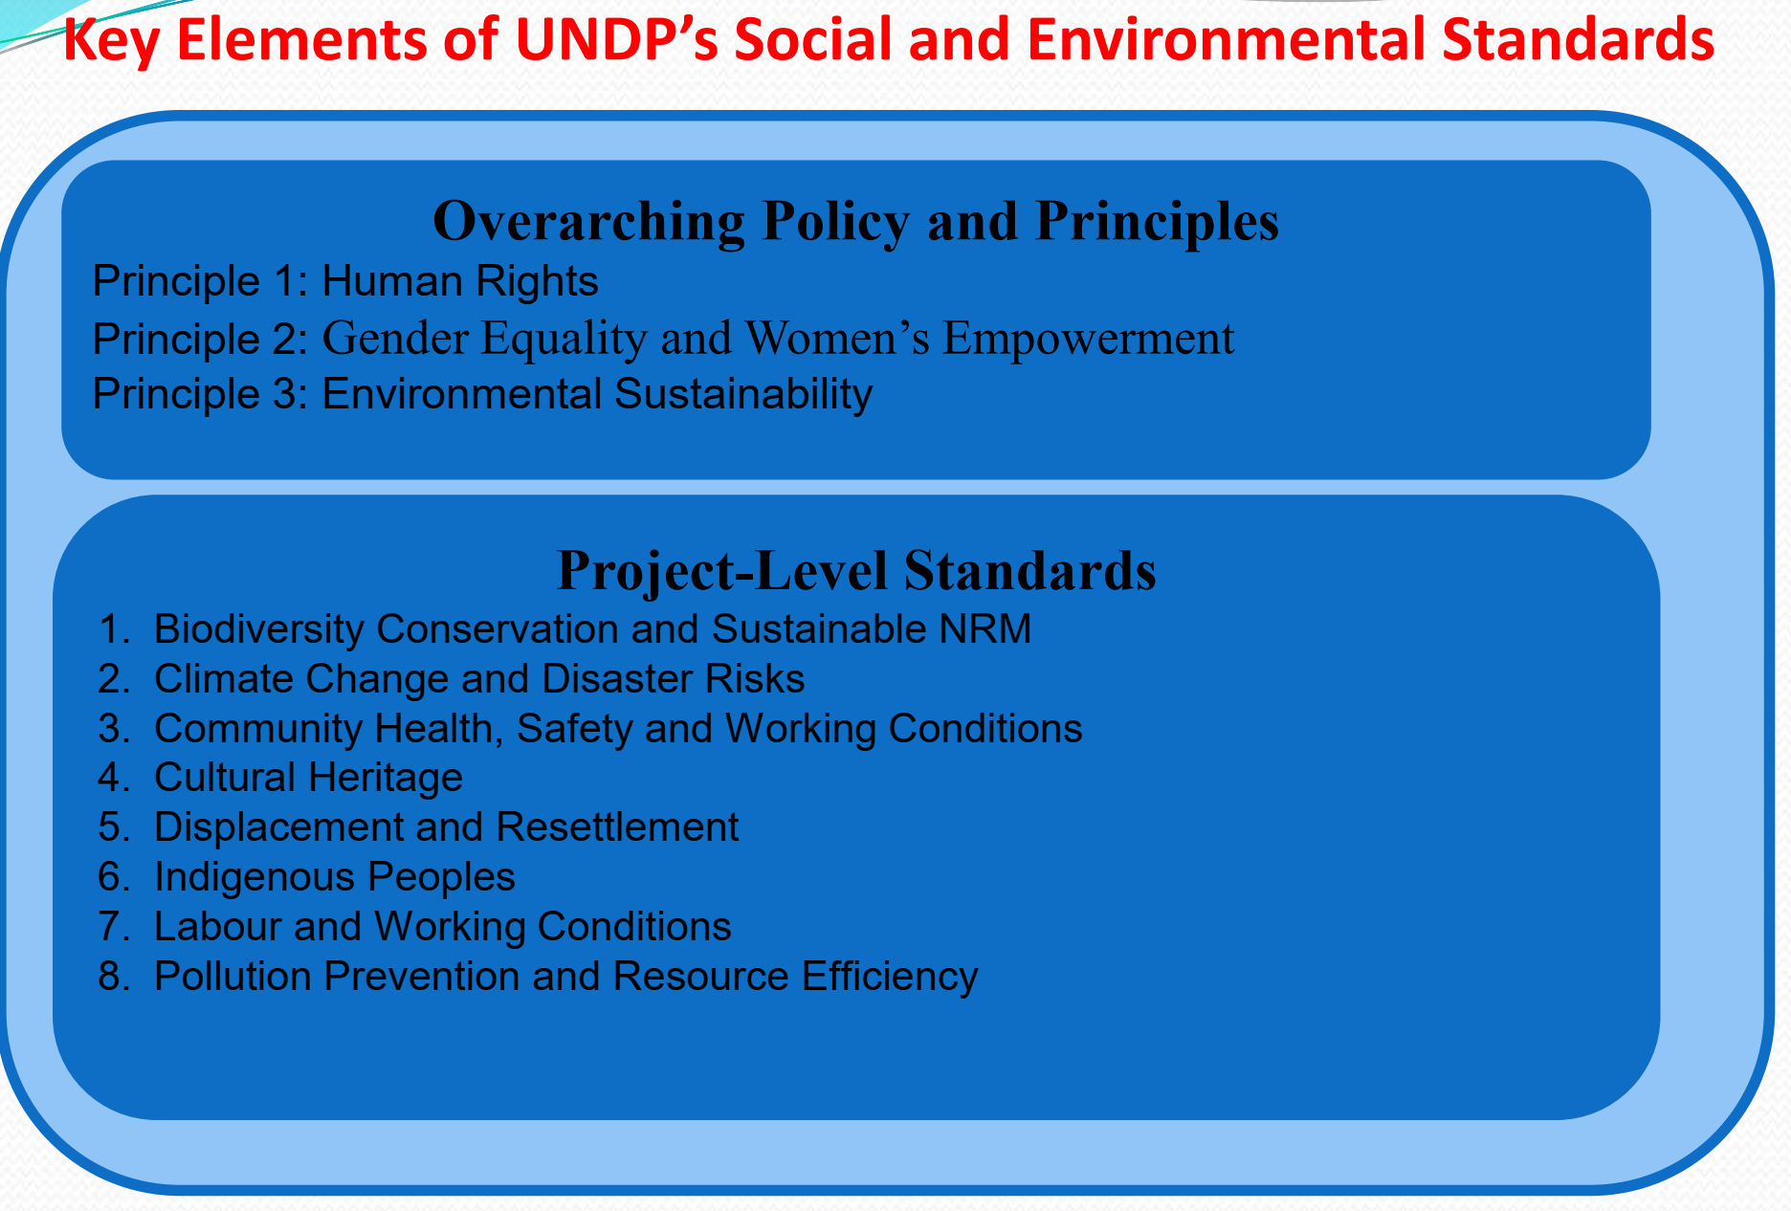
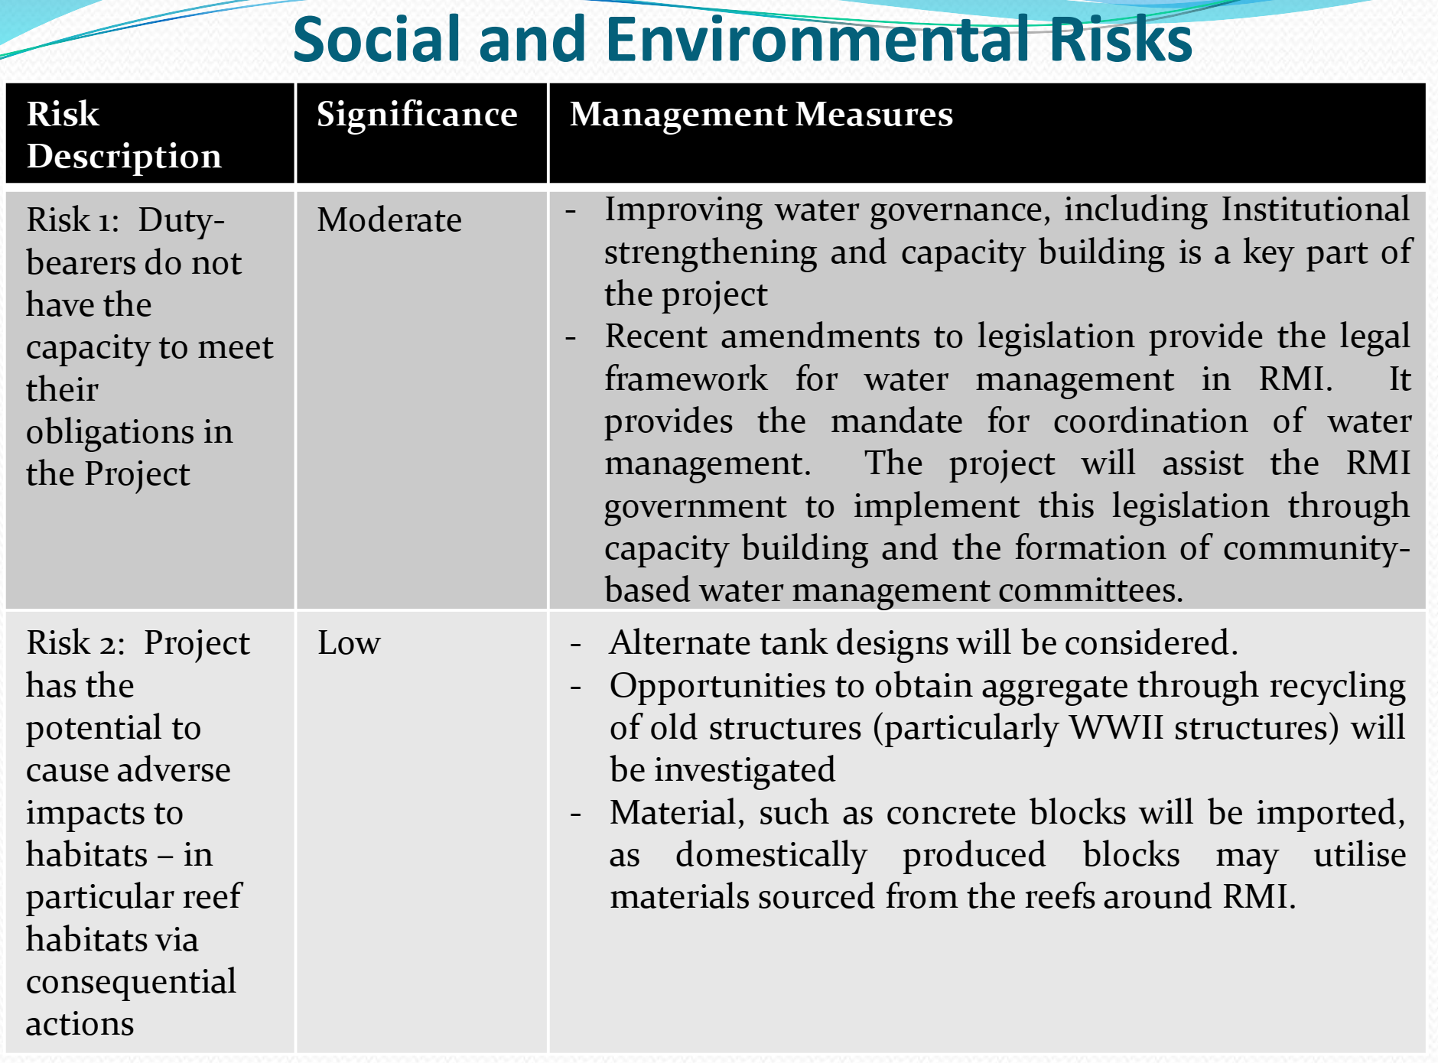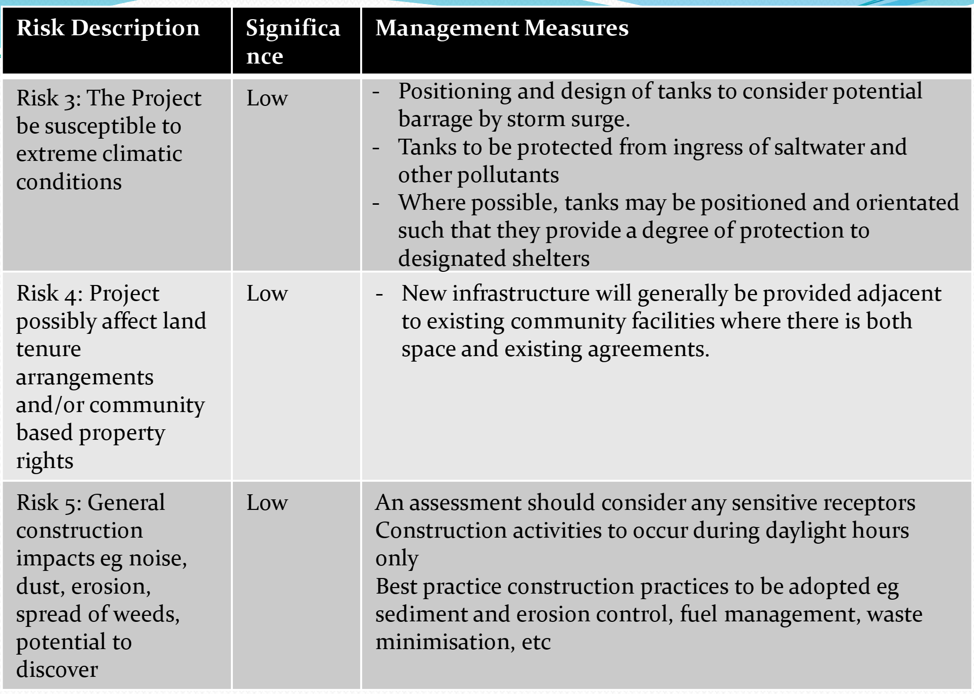
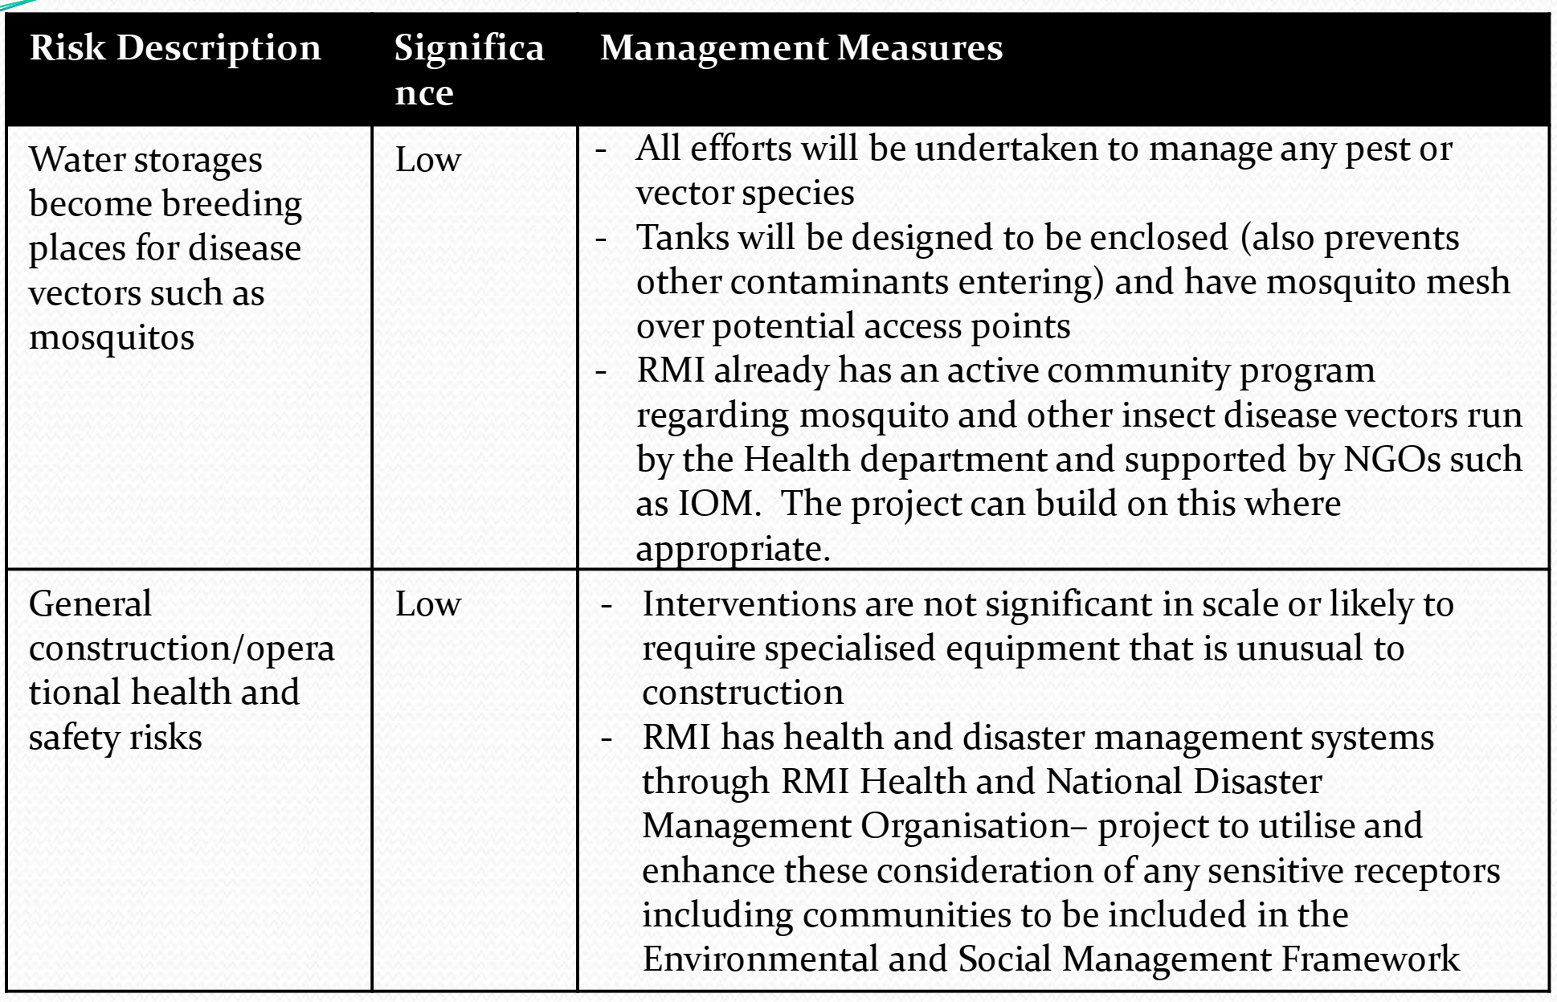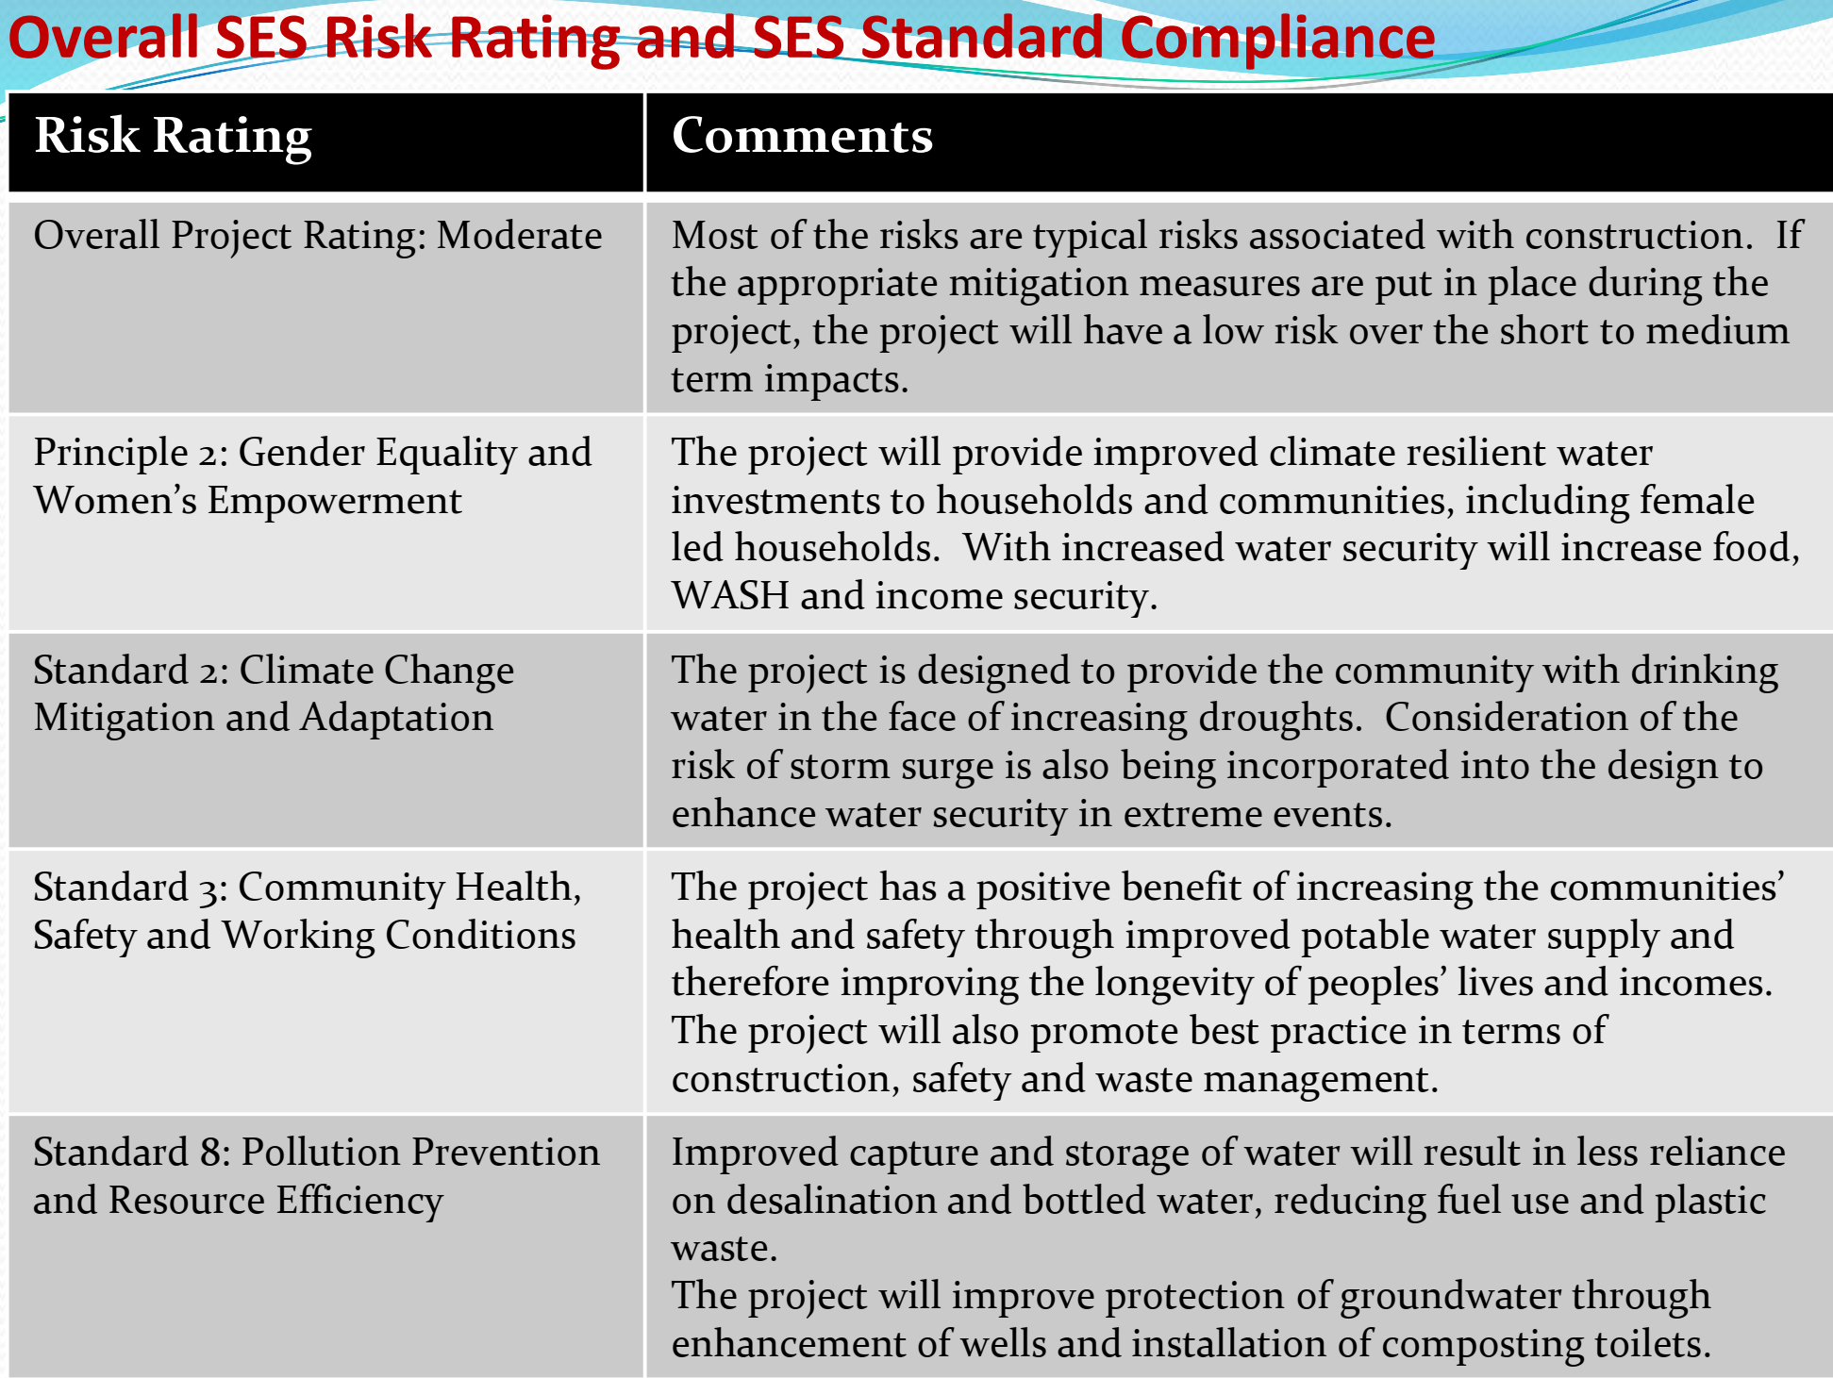
Session5
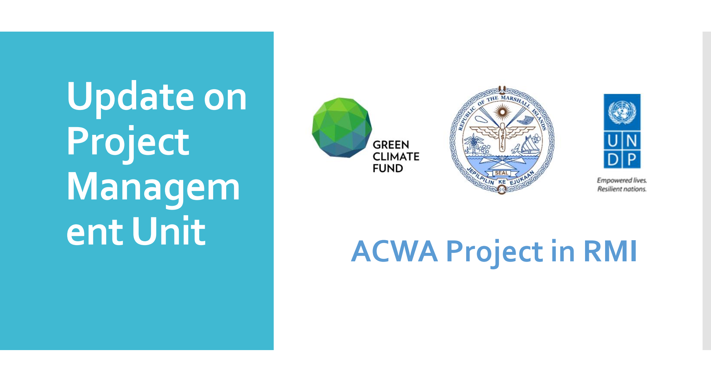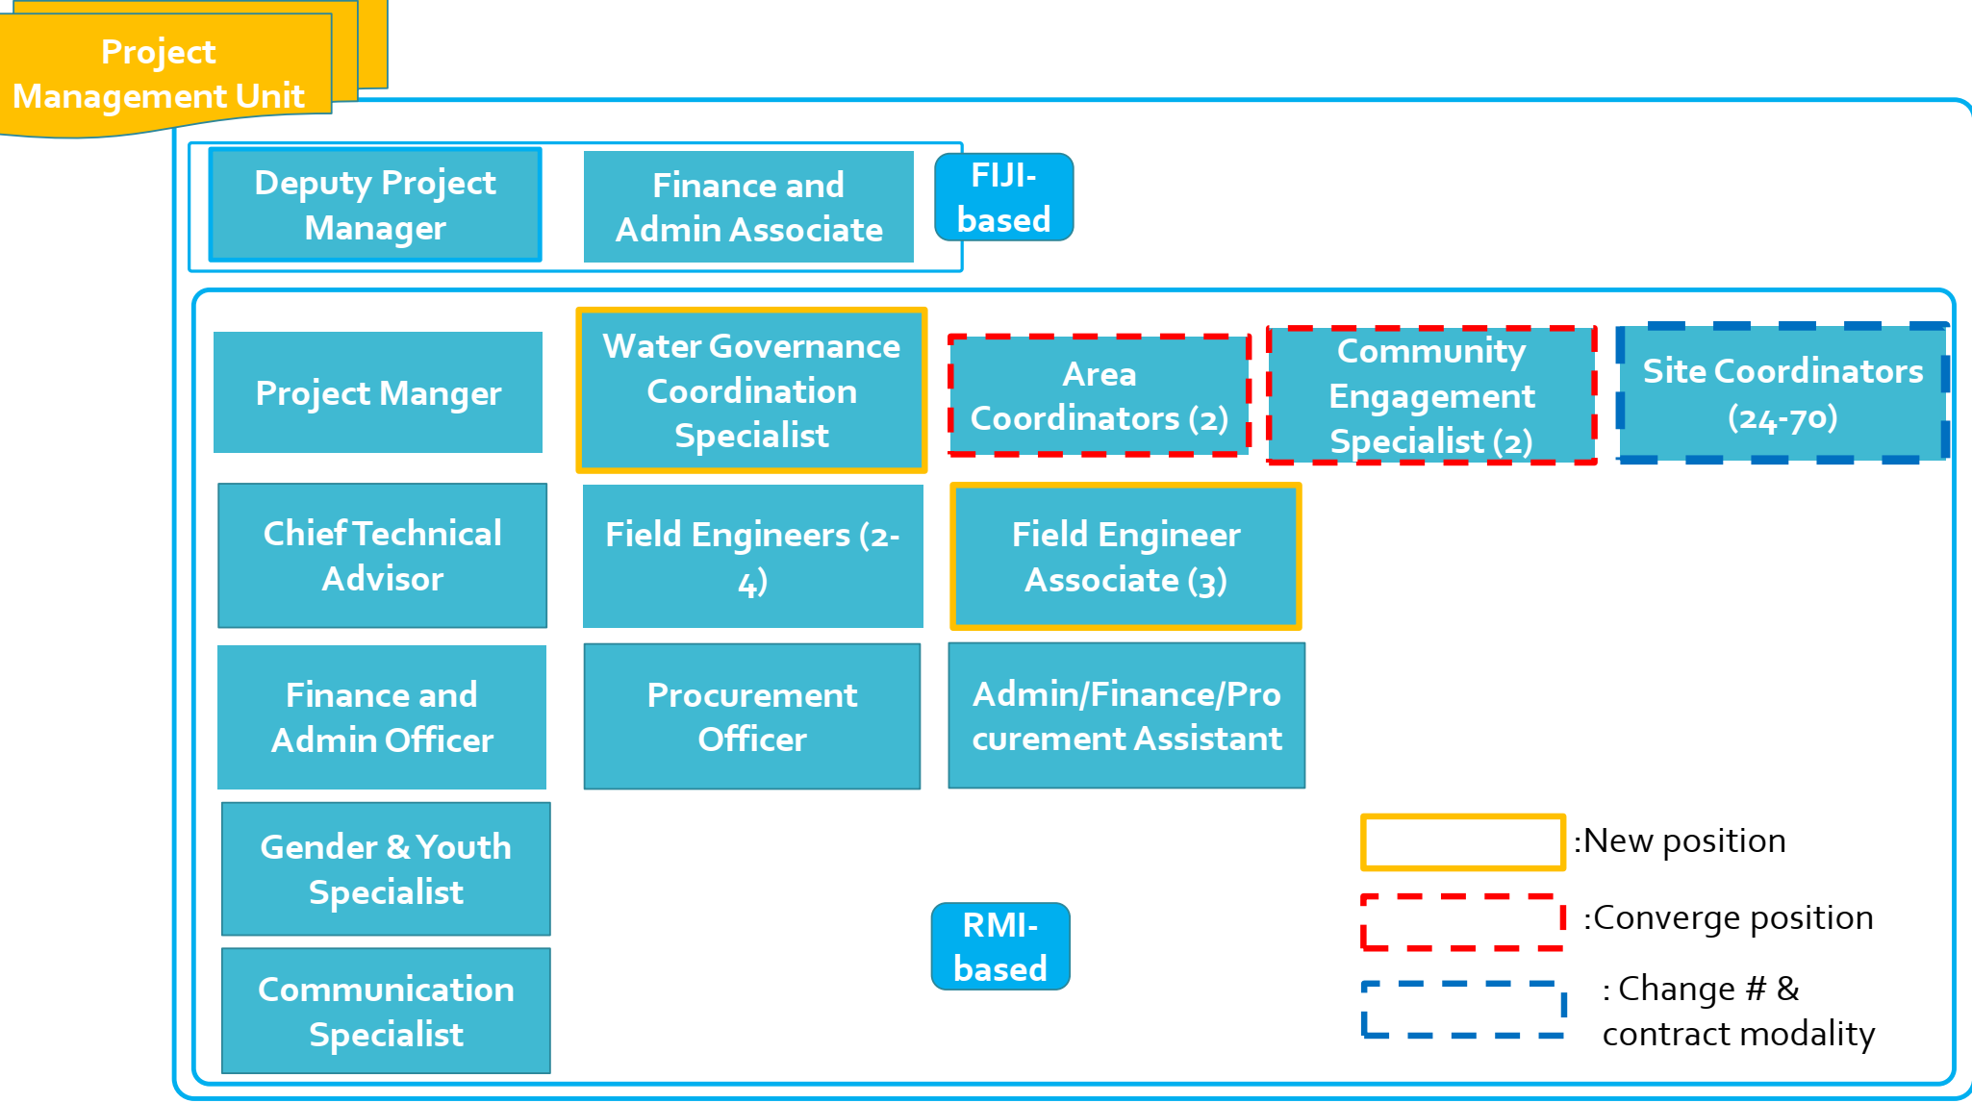
Session6
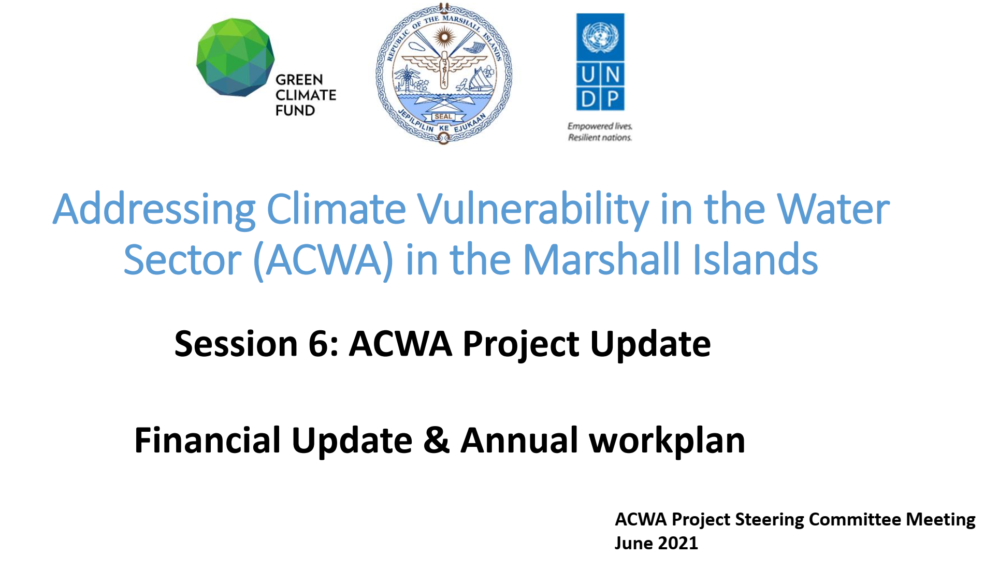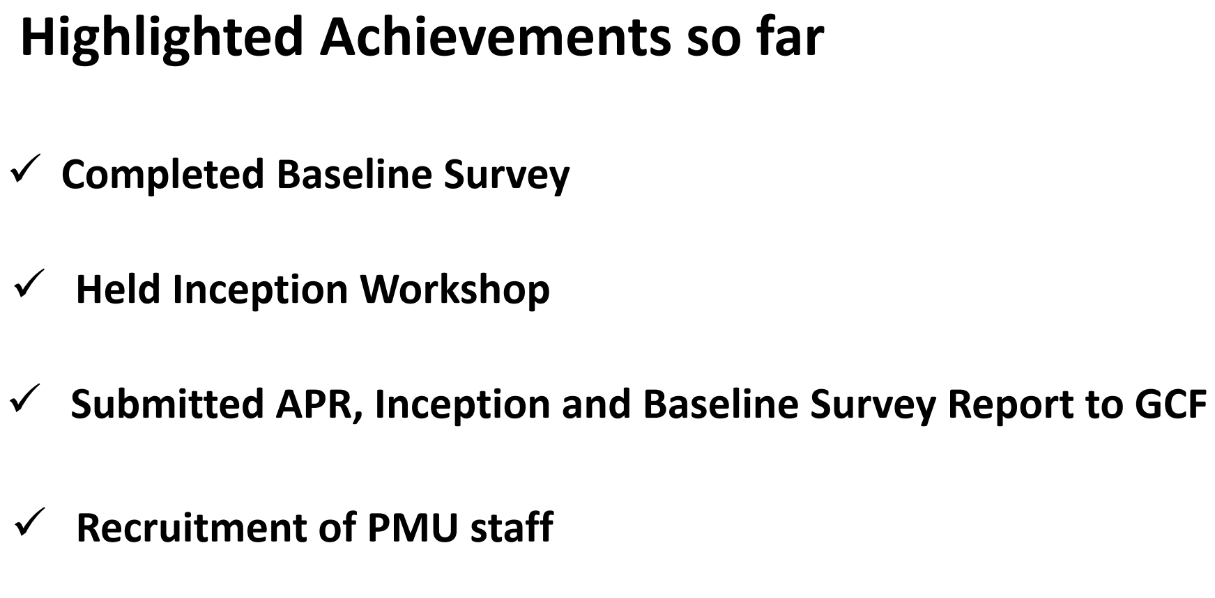
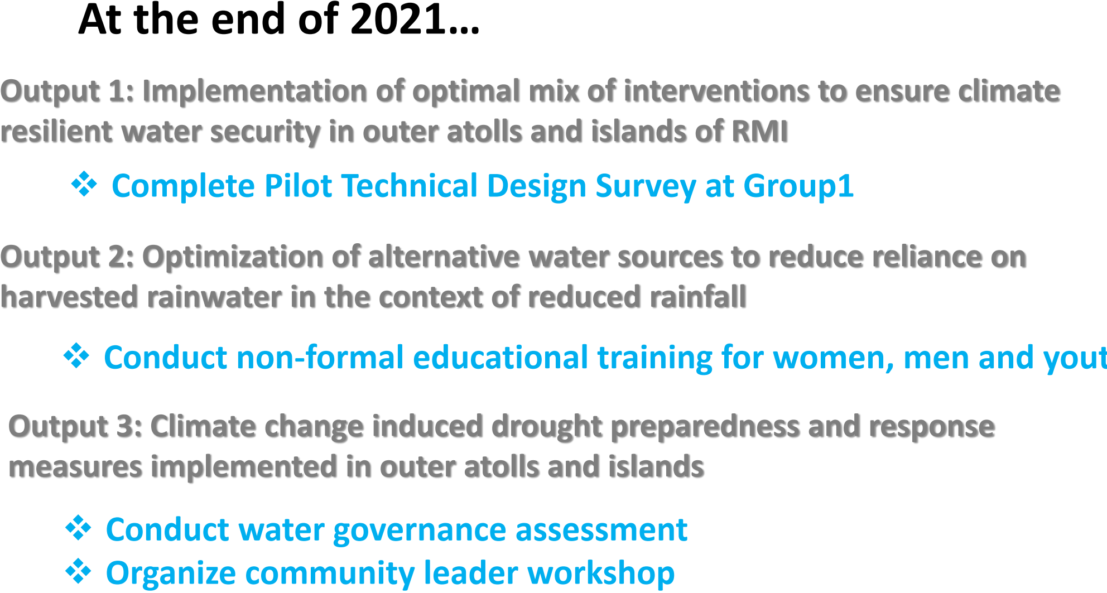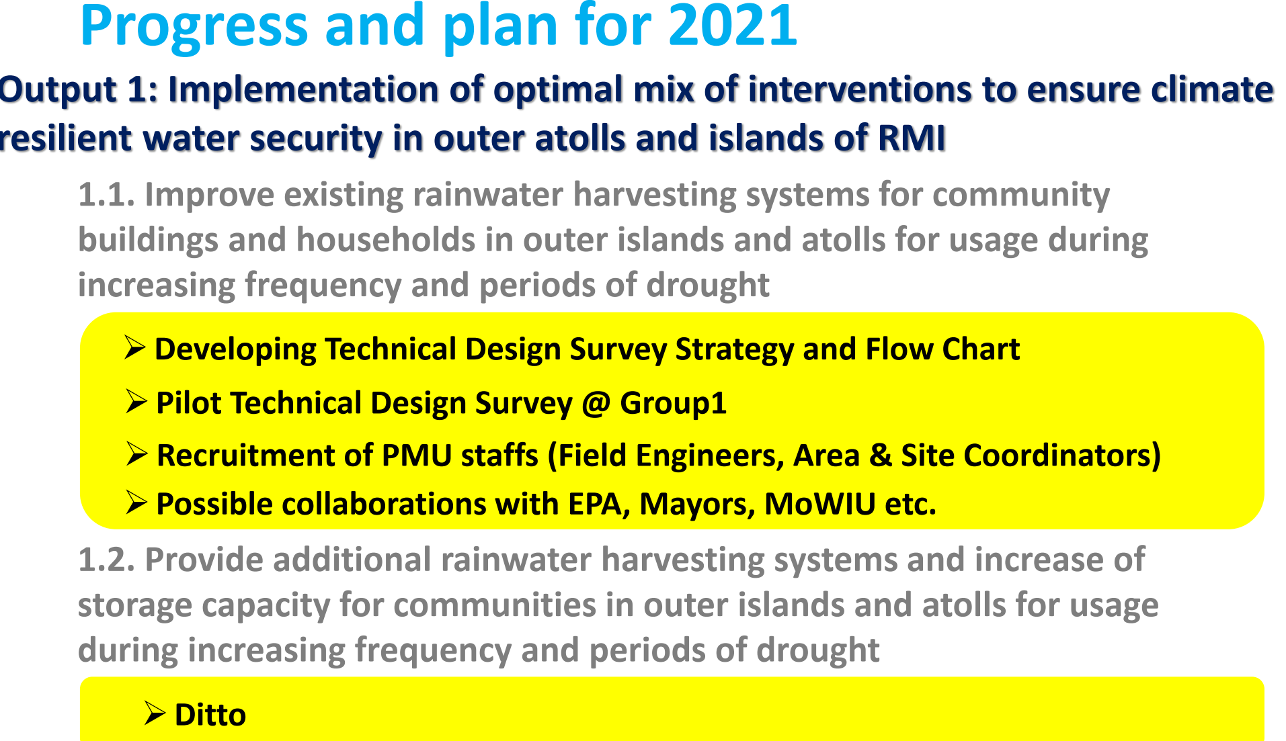
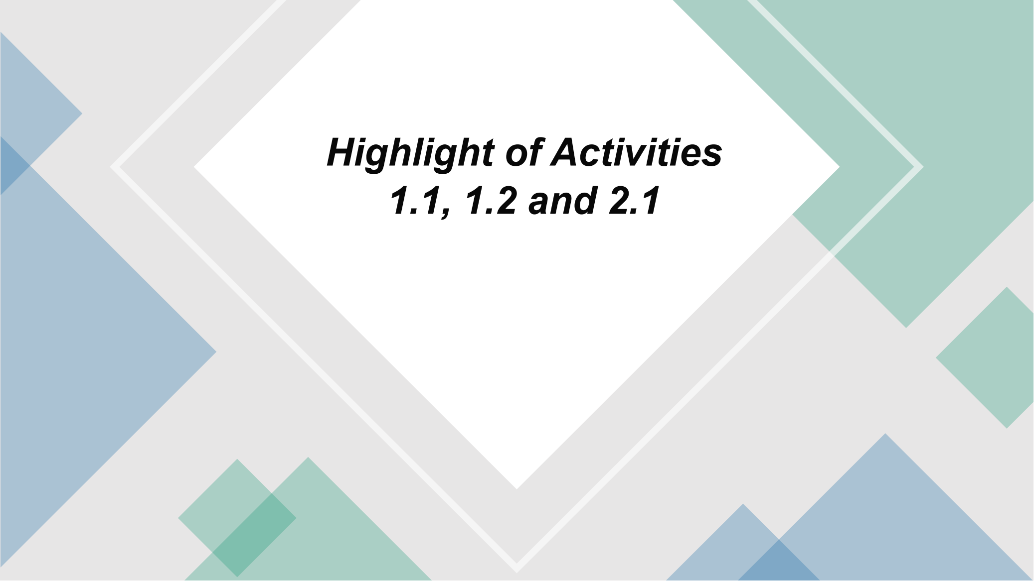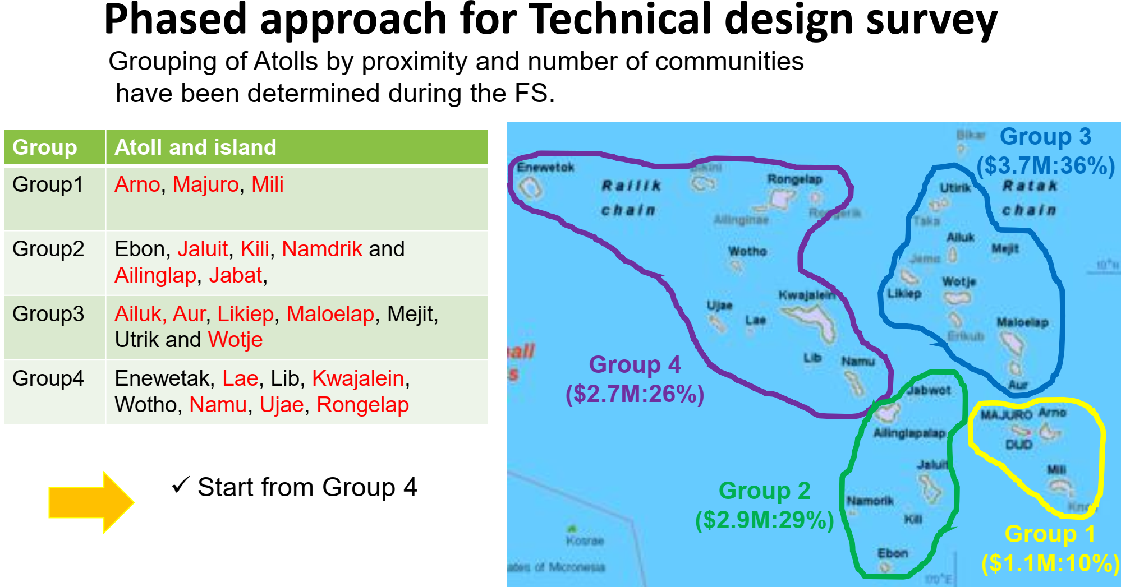

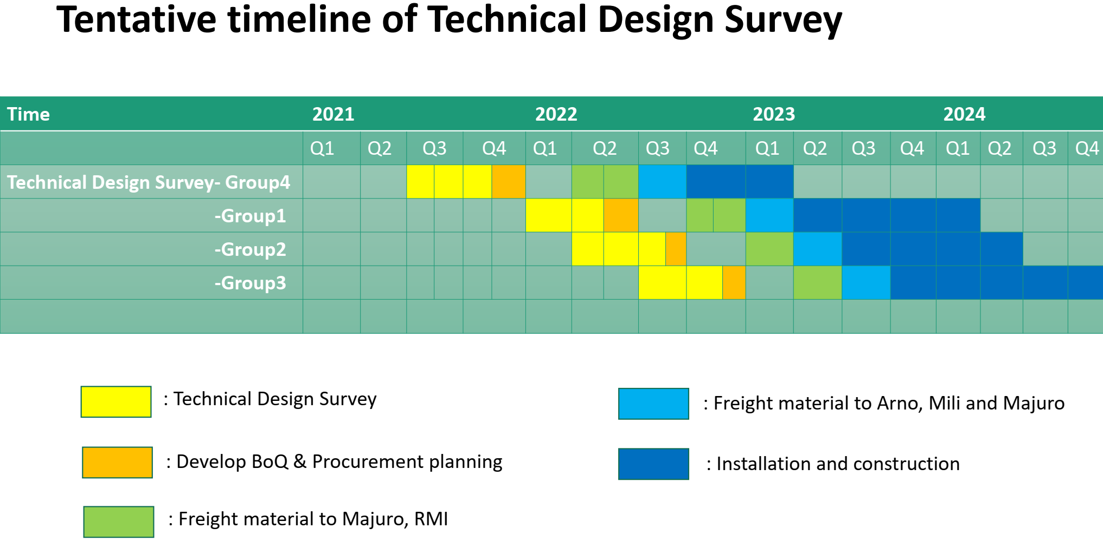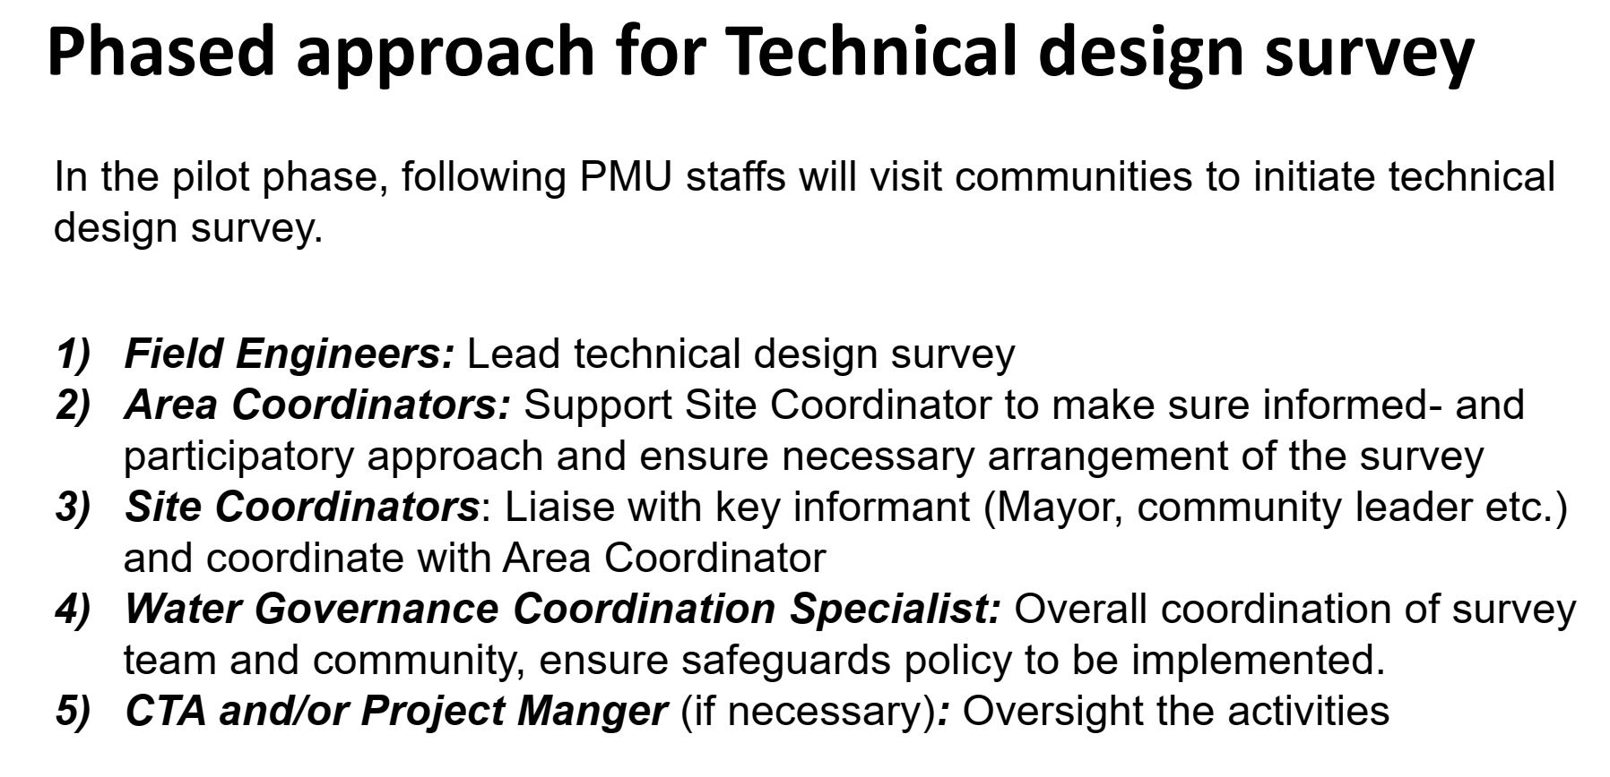
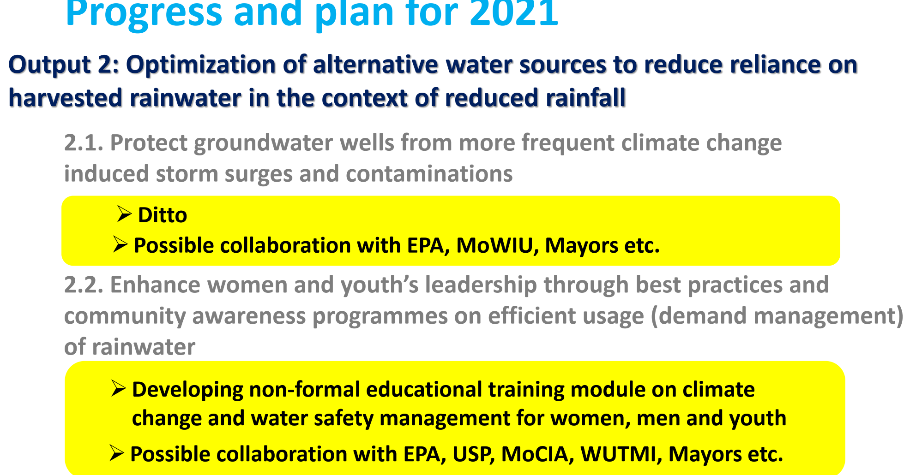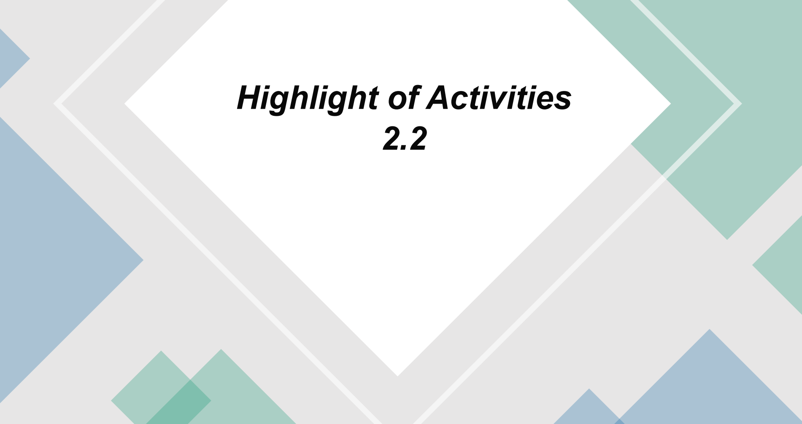
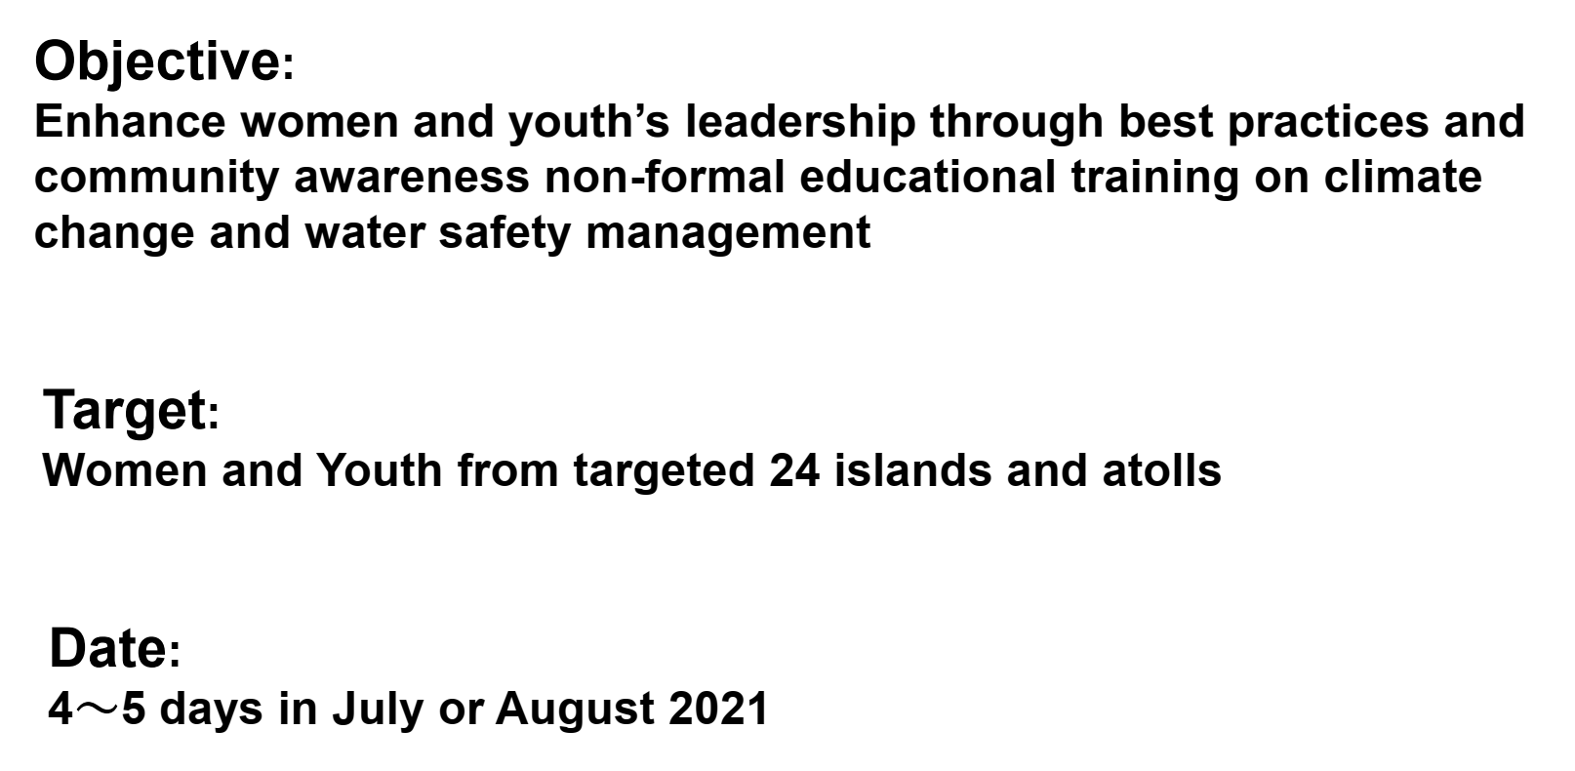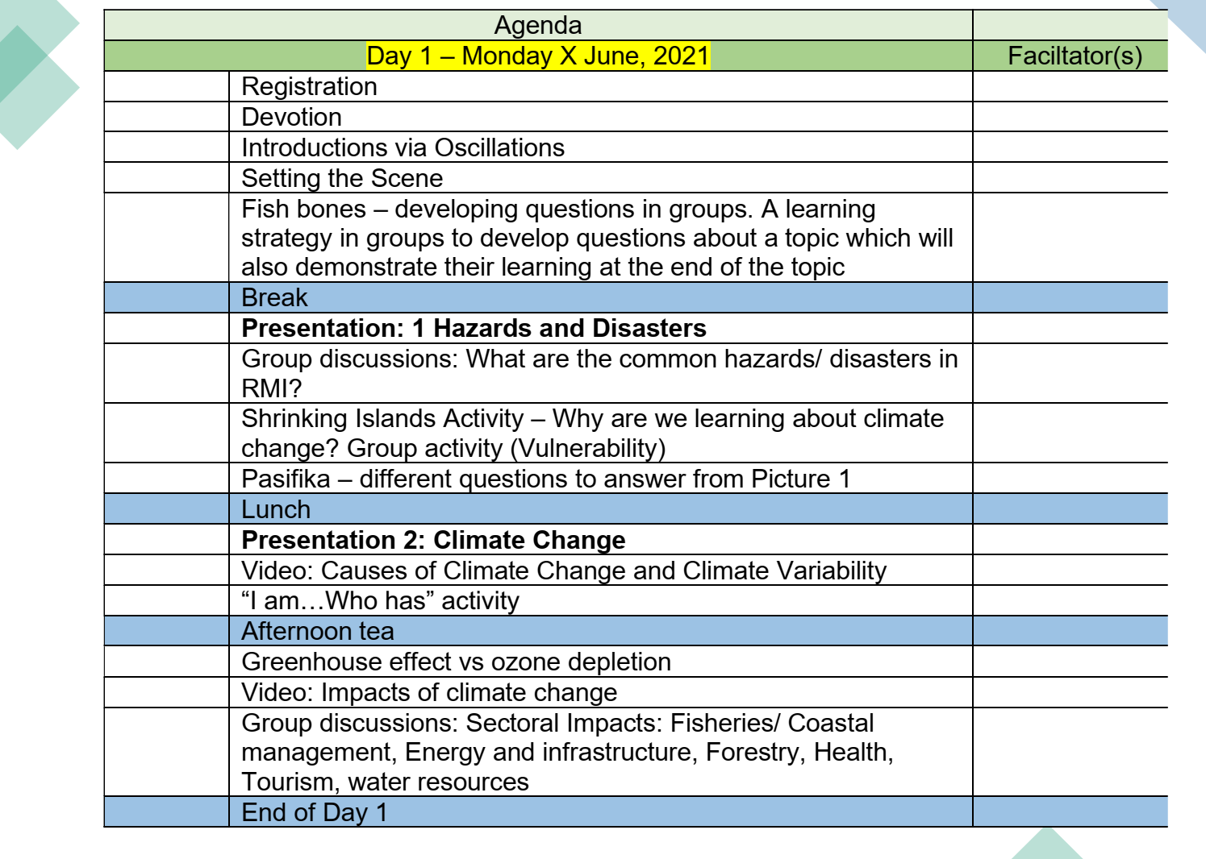

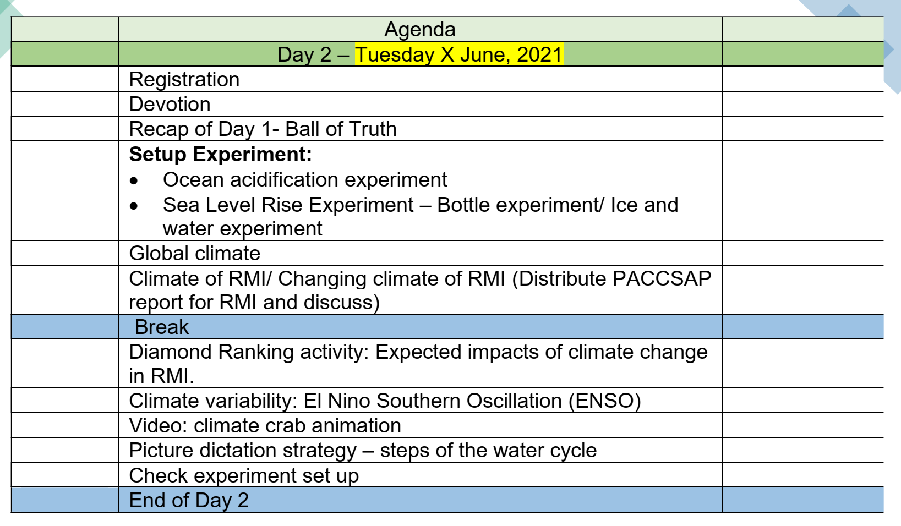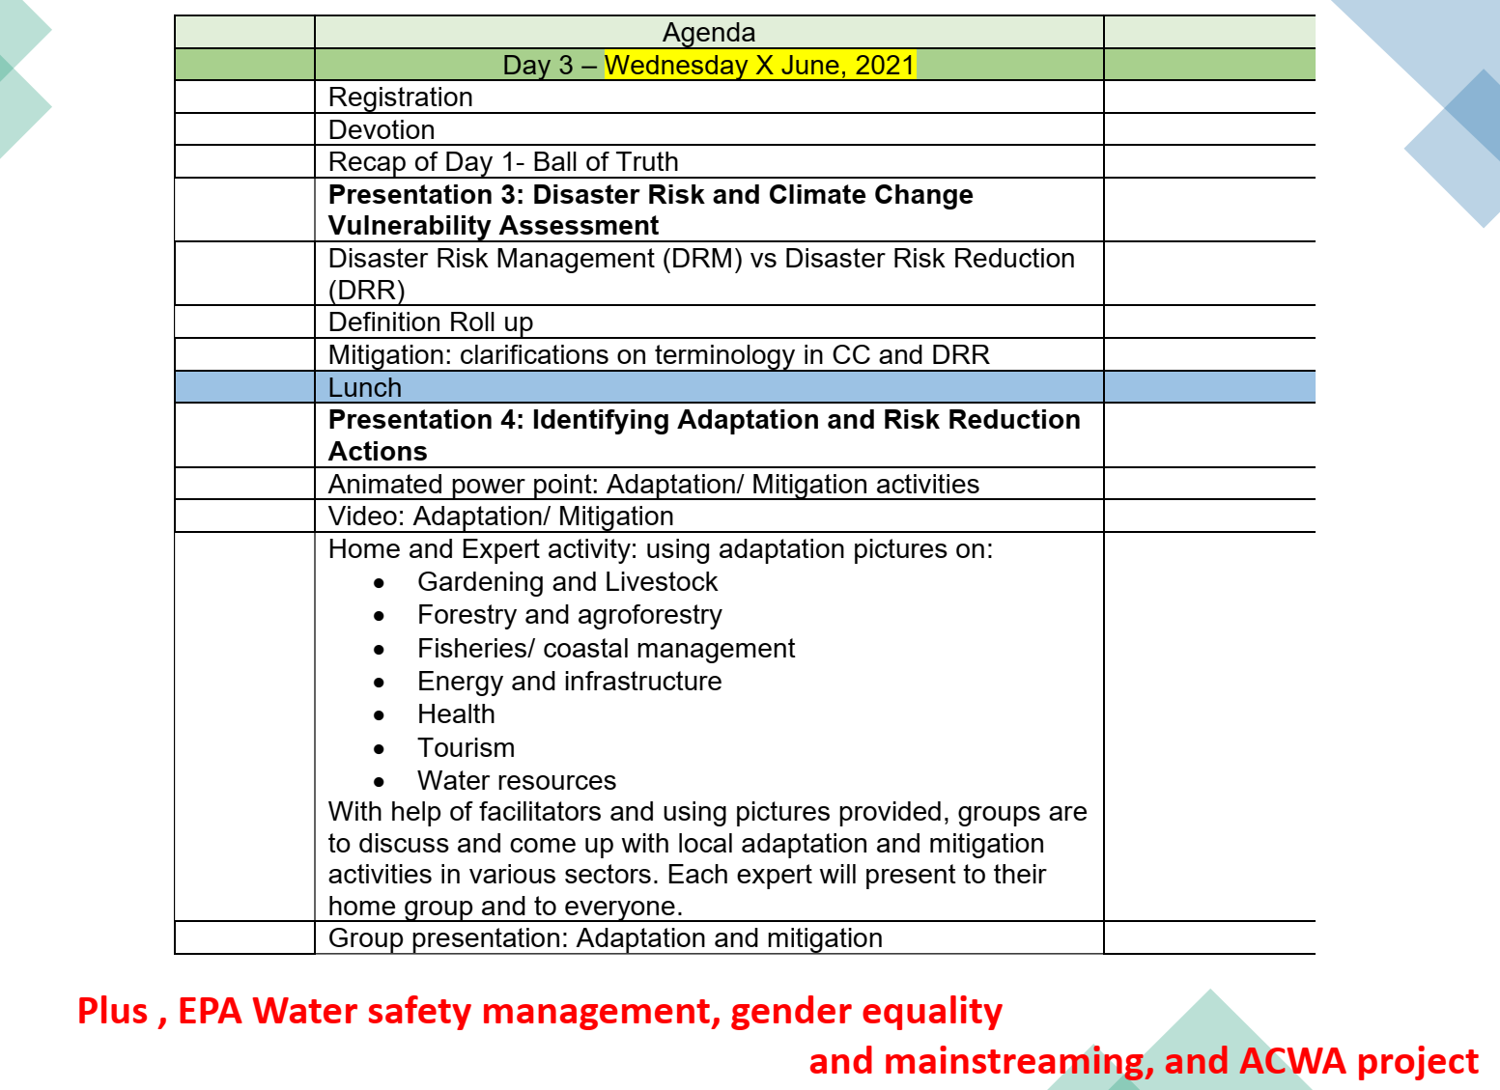
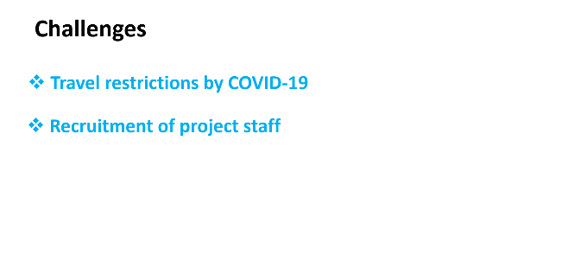
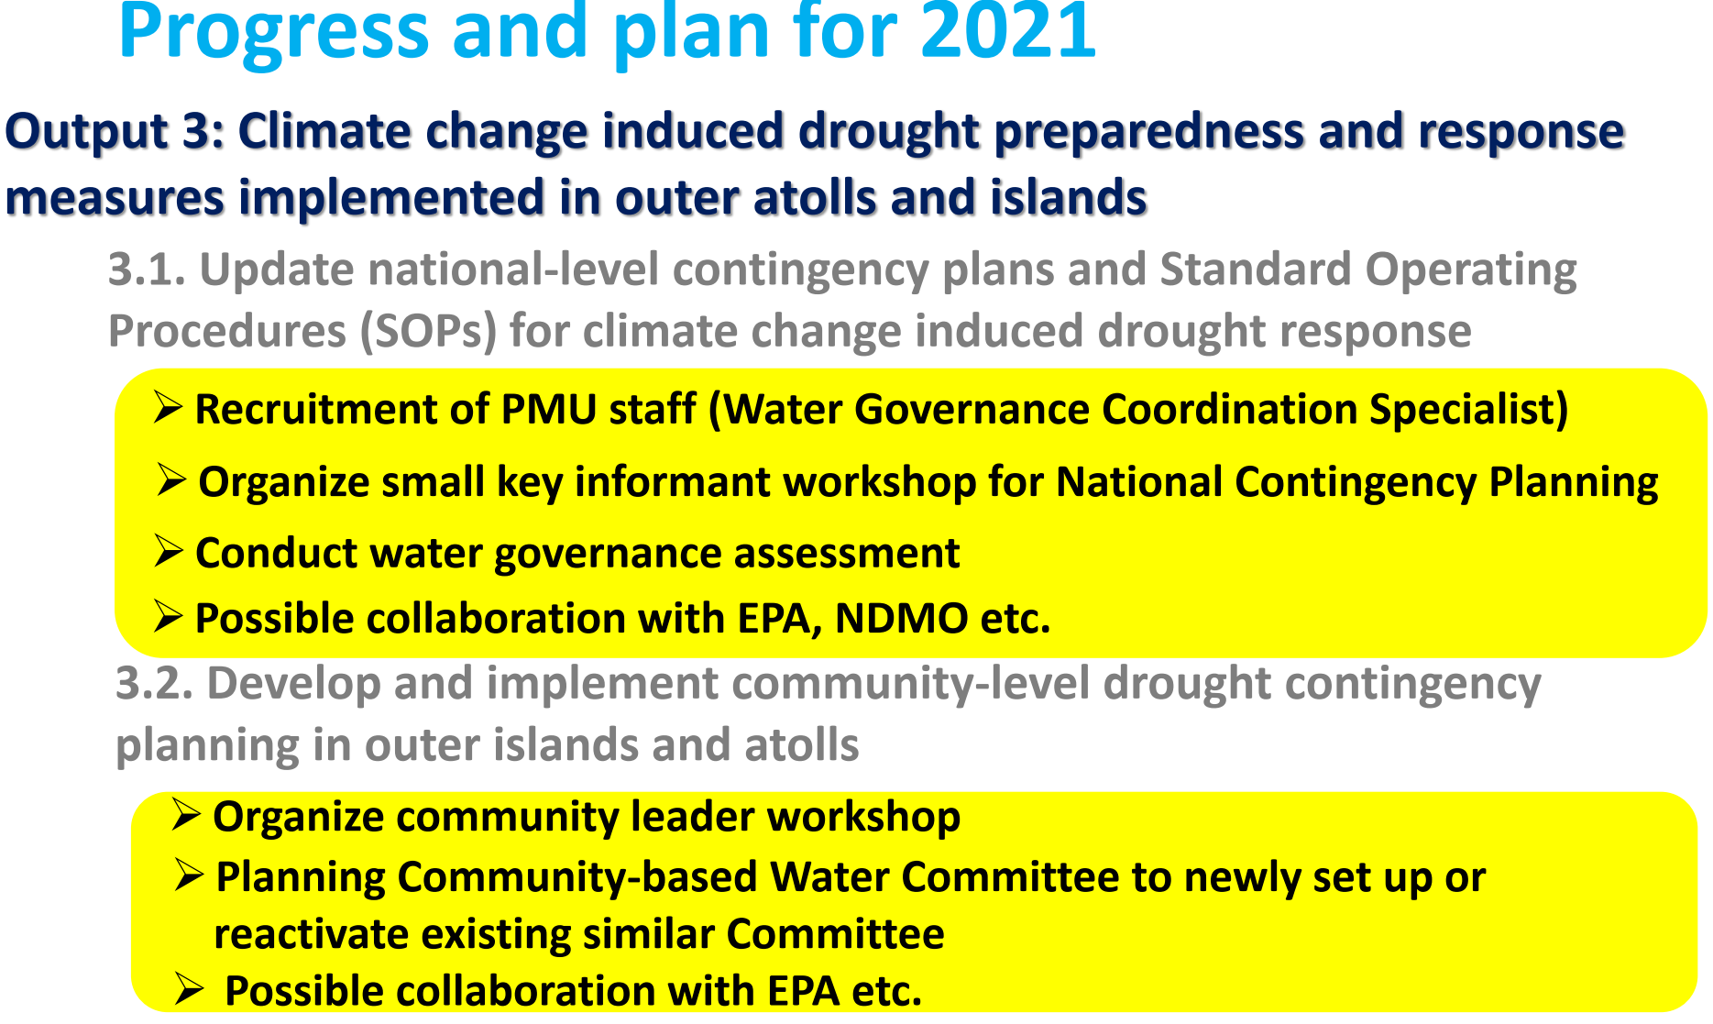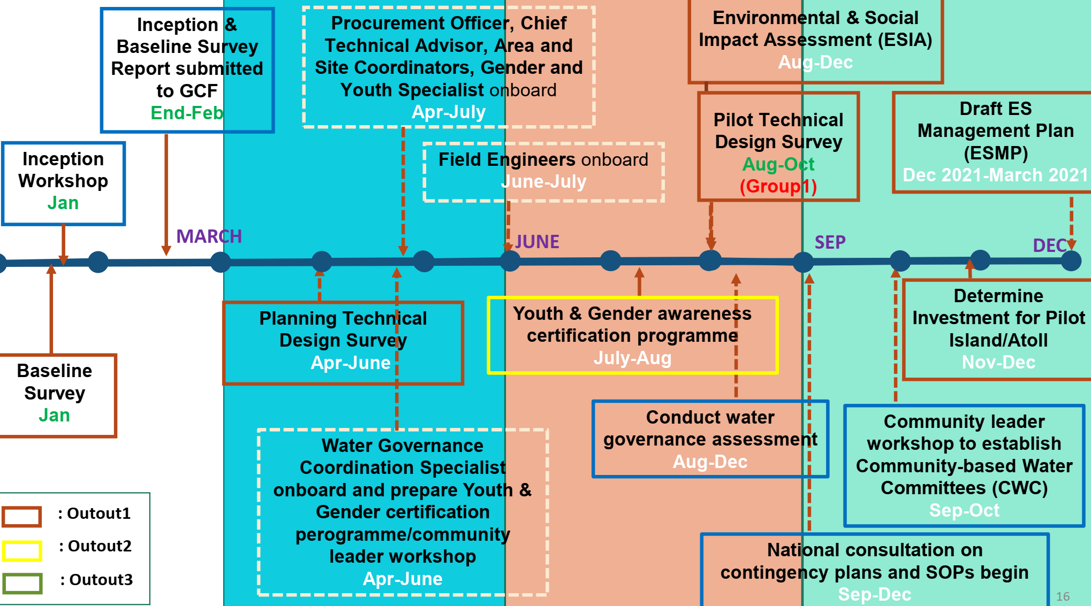
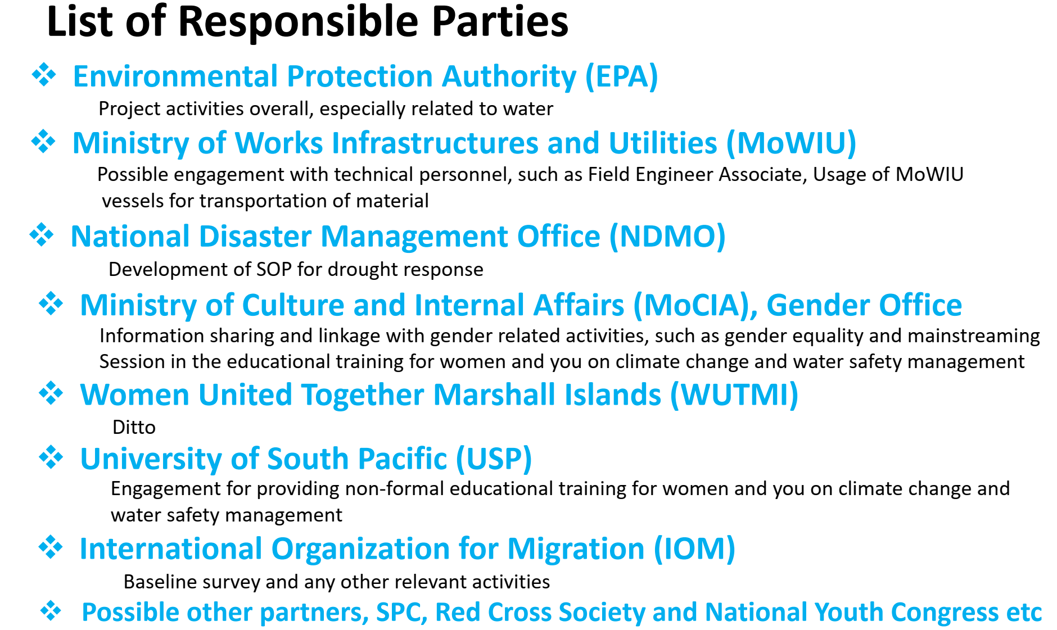

Session7
